DOUGHERTY AREA
REGIONAL
TRANSPORTATION
STUDY

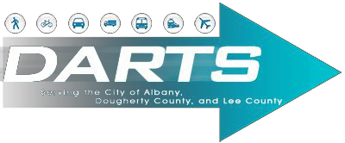

9/17/2020 PUBLIC PARTICIPATION PLAN
Table of Contents
SECTION I. INTRODUCTION .....................................................................................................................2

DARTS MPO BOUNDARY......................................................................................................................3

SECTION II. PURPOSE OF PARTICIPATION PLAN......................................................................................4

SECTION III. PARTICIPATION PLAN PROCESS FOR THE TRANSPORTATION PLAN..................................... 6

General Public Outreach Efforts........................................................................................................... 8

Process to Solicit Public Input in the Development and Update of the MTP.......................................... 9

Process to Solicit Public Input in the Development and Update of the Transportation Improvement
Program (TIP) .................................................................................................................................... 10

Process to Solicit Public Input in the Development and Update of the Unified Planning Work Program
(UPWP).............................................................................................................................................. 11

Process to Solicit Public Input in the Development and Update of the Participation Plan (PP) ............ 11

SECTION IV: AMENDMENT PROCESS & ADMINISTRATIVE MODIFICATIONS ......................................... 11

Metropolitan Transportation Plan (MTP) and Transportation Improvement Plan (TIP)....................... 11

Administrative Modifications............................................................................................................. 12

Amendments to the Metropolitan Transportation Plan (MTP) and Transportation Improvement Plan
(TIP)................................................................................................................................................... 12

Amendments to the Unified Planning Work Program (UPWP)............................................................ 13

Section V. General Responsibilities of the Citizens’ Transportation Committee (CTC) Regarding the
Public Involvement Process .................................................................................................................. 13

SECTION VI. DARTS TRANSPORTATION COMMITTEE MEMBERS........................................................... 15

Policy Committee Voting Members................................................................................................ 15

Citizens’ Transportation Committee Members............................................................................... 15

Technical Coordinating Committee Members ................................................................................ 15

Technical Coordinating Committee Non – Voting Members ........................................................... 16

APPENDIX A. GLOSSARY OF TERMS ...................................................................................................... 17
SECTION I. INTRODUCTION
This public participation process for the Long Range Transportation Plan, Transportation Improvement Program, Special Projects, other plans and programs satisfies the Federal Transit Administration’s Program of Projects public participation requirement for Georgia Department of Transportation and participating transit grantees in the DARTS urbanized area, including Albany Transit System.
In accordance with 23 CFR 450.316, the Dougherty Area Regional Transportation Study (DARTS) is required to engage in a metropolitan planning process that creates opportunities for public involvement, participation, and consultation throughout the development of the Metropolitan
Transportation Plan (MTP) and the Transportation Improvement Program (TIP). Under this requirement, DARTS must allow for:

- Adequate public notice of public activities
- Review and comment at key decision points in the development of the MTP and TIP
- Multiple, accessible participation formats, including electronic and in-person
- Seeking out and considering the needs of those traditionally underserved

DARTS should develop a collaborative and comprehensive Participation Plan, with the public and stakeholder communities, to be used in the development of the MTP and TIP, as well as to frame the strategies for public and stakeholder communication in all phases of the planning process. The Participation Plan itself must be prepared by DARTS with a 45-day public review and comment period.
DARTS MPO BOUNDARY

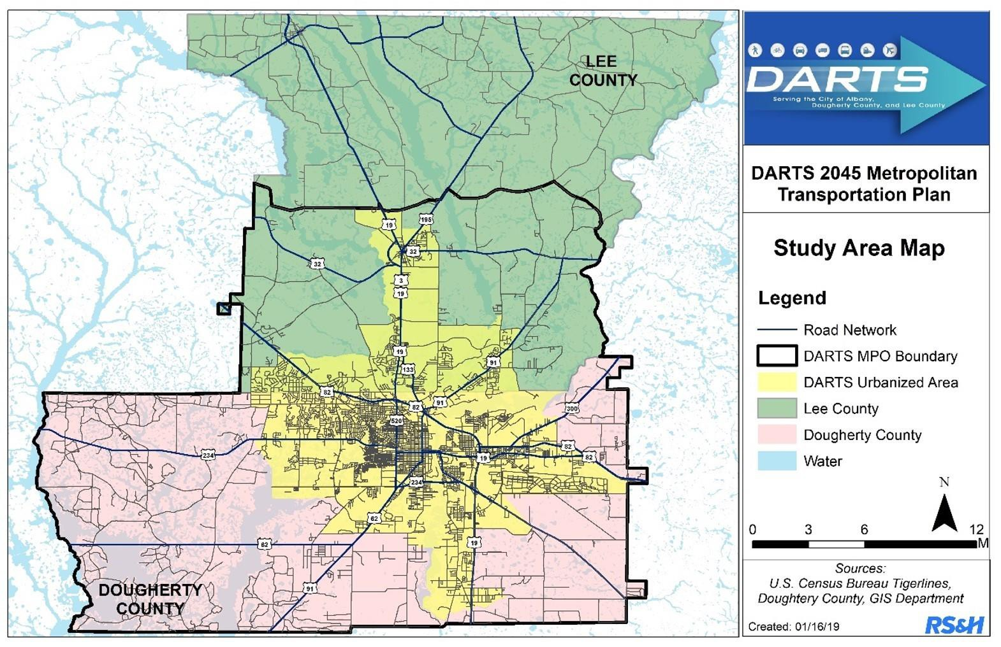
SECTION II. PURPOSE OF PARTICIPATION PLAN

The Participation Plan is required by law under the Fixing America's Surface Transportation Act (FAST) which underscores the need for public involvement. It requires metropolitan planning agencies such as DARTS to provide a process for providing citizens, affected public agencies, representatives of public transportation employees, freight shippers, providers of freight transportation services, private providers of freight transportation services, private providers of transportation, representatives of users of public transportation, representatives of users of pedestrian walkways and bicycle transportation facilities, representatives of the disabled and other interested parties with a reasonable opportunity to respond to key transportation issues that affect the DARTS region.

The MPO in coordination with local governments, local transportation agencies, the Georgia Department of Transportation (GDOT), Federal Highway Administration (FHWA) and Federal Transit Administration (FTA) conducts the transportation planning process. The FAST Act has not changed the existing Metropolitan Planning Organization (MPO) planning goals or the process of administering federal planning funds to the MPOs. Under the FAST Act these planning factors remain unchanged. The ten (10) planning factors are as follows:

1. Support the economic vitality of the metropolitan area, especially by enabling global competitiveness, productivity, and efficiency;
2. Increase the safety of the transportation system for motorized and non-motorized users;
3. Increase the security of the transportation system for motorized and non-motorized users;
4. Increase the accessibility and mobility of people and for freight;
5. Protect and enhance the environment, promote energy conservation, improve the quality of life, and promote consistency between transportation improvements and State and local planned growth and economic development patterns;
6. Enhance the integration and connectivity of the transportation system, across and between modes, for people and freight;
7. Promote efficient system management and operation, and;
8. Emphasize the preservation of the existing transportation system.
9. Improve the resiliency and reliability of the transportation system and reduce or mitigate stormwater impacts of surface transportation
10. Enhance travel and tourism

Among the specific areas (identified by DARTS), the state and federal government to consider in designing this process include:
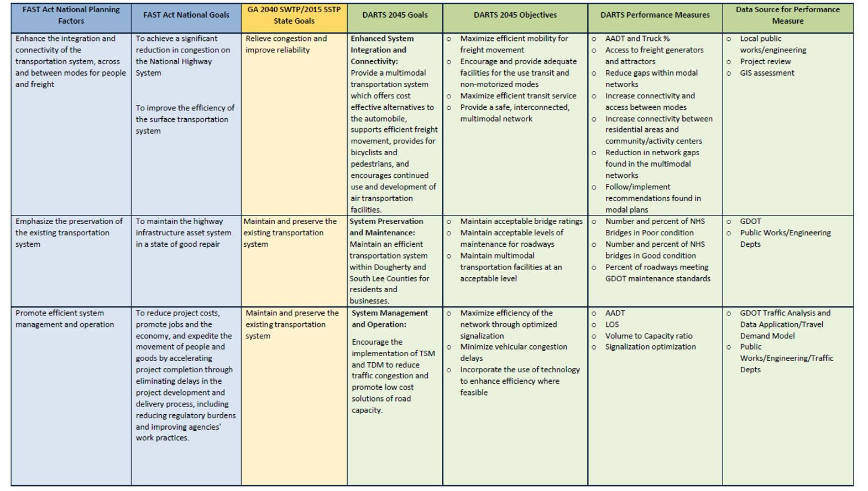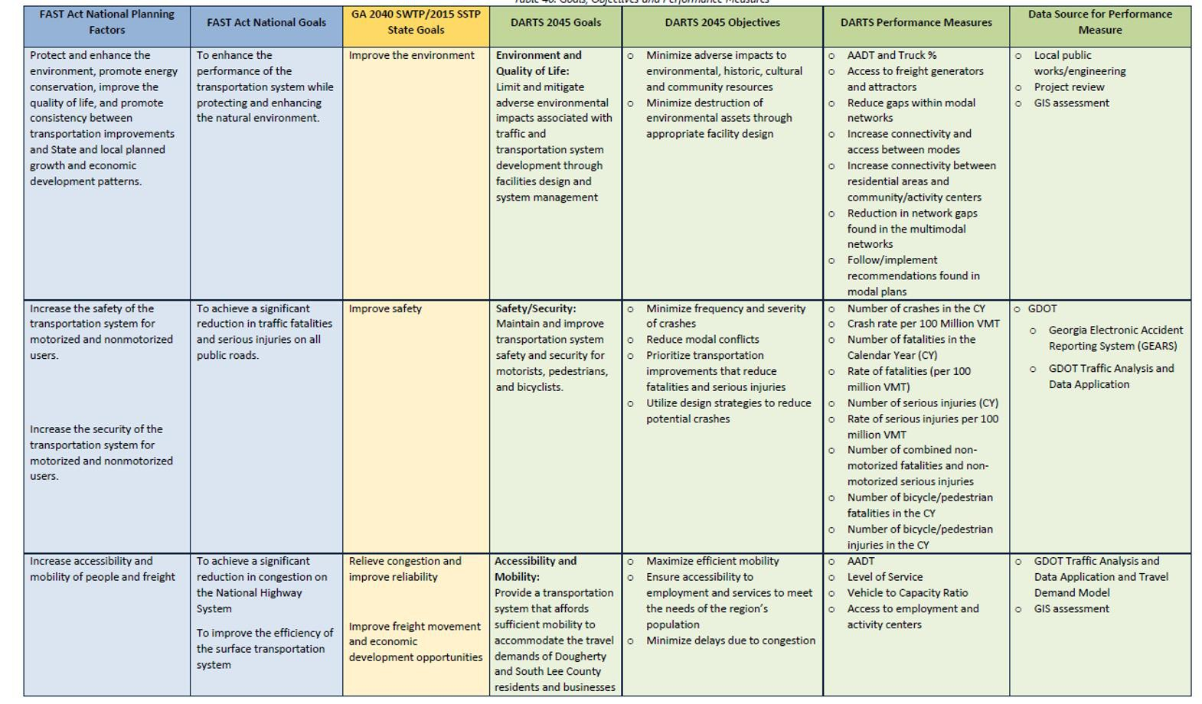

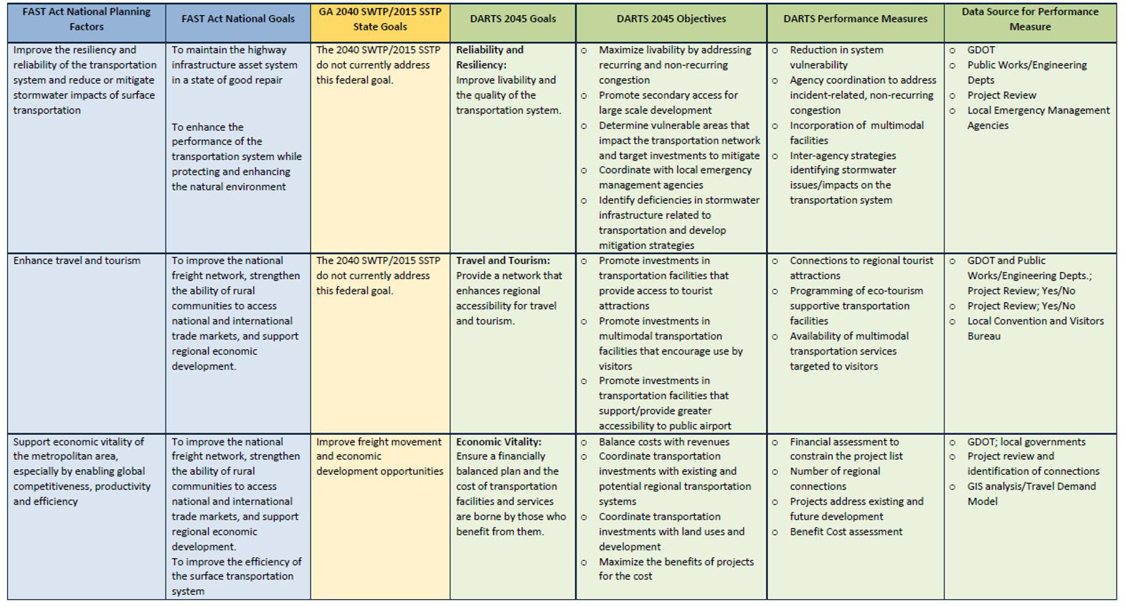Page 5

The following sections illustrate efforts to incorporate a proactive participation process into the DARTS planning process and general responsibilities. The public involvement process for the Metropolitan Transportation Plan (MTP) and Transportation Improvement Program (TIP) is used to satisfy the Federal Transit Administration’s (FTA) public participation requirements related to the development of the Section 5307 Program of Projects. This includes such specific areas as updates to the DARTS transportation plan and the Transportation Improvement Program (TIP).

SECTION III. PARTICIPATION PLAN PROCESS FOR THE TRANSPORTATION PLAN
Public Input

Public Input is needed in the update and amendment process to transportation plans including the TIP
and MTP.

DARTS Policy Committee (PC)

The DARTS Policy Committee (PC), which consists of elected officials and staff representing
the jurisdictions, transportation providers and other significant interests in the MPO area, is responsible for ensuring that future plans are functionally sound, financially feasible, and generally conform to the
goals and objectives of the state, region, and local community. The PC also provides guidance and leadership for implementation.

Citizens Transportation Committee (CTC)

The Citizens Transportation Committee (CTC) functions as an information dissemination and review group. The CTC includes a cross section of representatives of the community including those typically underrepresented in the transportation planning process. The CTC includes representation from all geographic areas within the planning area. The CTC reviews and provides feedback and input on the development and projects, including the MTP and TIP. Input from the CTC and review and considered by the Technical and Policy Committees.

Technical Coordinating Committee (TCC)

The Technical Coordinating Committee (TCC) consists of transportation planners, engineers, and transit providers representing local, regional, and state agencies. The TCC is charged with the responsibility of reviewing DARTS plans and recommendations, providing technical guidance to the Policy Committee an d the Citizens Advisory Committee, and to ensure that plans and recommendations made by DARTS do n to conflict with other plans or programs underway in the metropolitan planning study area. As plans an d alternatives are prepared and approved by this committee, they are presented to the Policy Committee e for final adoption.

Other Agencies

State/Federal/Local

U.S. Department of Transportation (US DOT)

Works with local and state officials to ensure that the 3-C planning process as required by the 1962
Highway Act which stipulates that a cooperative, comprehensive, and continuing planning process be carried out. This process was further addressed in the 1974 Federal Aid Highway Act, which stipulated that all urbanized areas required to have a 3-C planning process also create local Metropolitan Planning Organizations (MPO).

Georgia Department of Transportation (GDOT)

Responsible for the coordination of the state aspects of any studies, assist in the preparation of
analytical techniques as well as play a major role in the development and utilization of computer models for the study.

Planning & Development

Responsible for developing the local work program and provides staff services for the Dougherty Area Regional Transportation Study. The Director of the Planning & Development acts as DARTS project Director and serves as the Chairman of the Technical Coordinating Committee.

1. An Update to the Transportation Plan will consist of the deletion of a project from the Plan, the addition of a project to the Plan, or major changes in the design or scope of a project.
2. Updates to the adopted Transportation Plan will follow the DARTS committee structure for the review of projects. This consists of review of the changes by the following committees: 1) TCC, 2) CTC, and 3) the Policy Committee. The TCC and the CTC will forward any comments or recommendations regarding the change to the Policy Committee.
3. Notice of changes to the Transportation Plan will be given in local newspapers at least 15 days before the proposed amendment is reviewed by the CTC. The public notice will invite public comments at this meeting. The CTC will forward a recommendation to the DARTS Policy Committee regarding the proposed Plan amendments.
4. The general public will be given yearly the opportunity to comment on the projects in the Transportation Plan. This will generally be coordinated with the public informational meeting associated with the TIP.
5. If an individual or group is concerned about a transportation project or policy, they shall address the CTC regarding the issue. The CTC will forward a recommendation to the Policy Committee regarding the matter. The Chairperson of the CTC, who is a voting member of the Policy Committee, will brief the Policy Committee regarding the CTC’s findings. The individual or group may also address the Policy Committee with their concerns.

Albany Transit System

General Public Outreach Efforts
It should be noted that special participation procedures have been developed regarding the Metropolitan Transportation Plan (MTP), the Transportation Improvement Program (TIP), the Unified Planning Work Program (UPWP), the Participation Plan and other required planning documents:

a) Regularly Scheduled DARTS Transportation Meetings: The time, place, and date of all regularly scheduled meetings will be posted in the Governmental Building, the office of the Albany Dougherty Planning and Development, social media and the DARTS MPO website. The media will be provided notices of all Policy, TCC, and CTC meetings. Televised meeting notices will be also given on the local community access channel for regularly called Policy Committee meetings. In addition to the notices, an agenda of items to be discussed is also provided. Notice will be provided to the media and placed on the City’s website and social media at least five
days prior to regularly called Policy Committee meetings. Any changes to those meetings' dates, times, or locations will be provided to the media and posted on the City’s websites at least 48 hours prior to the meeting's start time.
b) Special-Called Meetings: The Chairman of each DARTS committee may call a special meeting provided that a notice of the time, place, and date of the meeting is posted 24 hours in advance of said meeting. The media will be notified of these meetings.
c) Agendas and Minutes: Agendas for each regularly called Policy Committee meetings will be available to committee members and the general public prior to each committee meeting. The minutes of all DARTS committees will be available at the next regularly scheduled meeting of the committee. Agendas and minutes will be posted on the DARTS website.
d) Social Media: The MPO will utilize appropriate social media avenues to post pertinent information and notices on a frequent basis. This also provides another opportunity for the public to provide public input to the MPO’s on-going planning process.
e) Virtual Meetings: The MPO will provide online participation opportunities as appropriate.
Virtual public meetings will include the same information provided at in-person public meetings
and will be advertised at the same time as in-person opportunities. DARTS will use social media, the DARTS website and other forms of online engagement tools to increase participation. Notice of all virtual public meeting be placed on the City’s website and social media at least five days prior to regularly called meetings. Any changes to those meeting dates or times will be provided at an adequate time.
f) DARTS Webpage: DARTS maintains a webpage. The URL for the webpage is
http://dartsmpo.org. Information related to DARTS planning activities and meeting times, dates, and locations is posted on a regular basis.
g) Open Meetings: All committee meetings will be open to the public. Exceptions to this policy will
be as provided by Georgia law.
h) Citizen Resource List: A database of interested parties will be maintained, and they shall be notified of all pertinent DARTS meetings. This list will be continually updated.
i) Public Notice/Review Period Guidelines for Planning Document: Public notices will be placed in local media, prior to all public review periods for miscellaneous plans. Public review periods for draft plans will run at least 15 days. Plans shall be made available for public review at the office of Planning & Development and Dougherty County libraries. If the final plan or program differs significantly from the one which was made available for public comment by the MPO and raises new material issues which interested parties could not have reasonably foreseen, an additional
15 days for public comment on the reviewed plan shall be made available.
j) Responses to Public Input: When significant public input is received on draft plans as a result of the public involvement process, a summary analysis, or report on the content of the comments and the responses shall be prepared and made part of the final document and shall be copied to those commenters.
k) Limited English Proficiency (LEP): Individuals identified as LEP are those whose primary language is not English and who have limited ability to read, speak, write, or understand English. LEP individuals can face difficulties in accessing important benefits or services, understanding and exercising important rights, complying with applicable responsibilities, or understanding other information provided by federally funded programs and activities. There are various tools and strategies the DARTS can use to help ensure that the needs of an LEP population are addressed. These tools include the early identification of members of the public who need language assistance, inclusion of materials in other languages, ensuring that DARTS staff are adequately trained to assist those needing language assistance. All public notices will given in both English and Spanish for LEP individuals.
l) ADA Consideration: Public notices will be given to the special needs for a hearing participant and requested in writing ten days prior to any public hearing. Other actions identified by the Policy Committee, which are necessary to comply with the Americans With Disabilities Act of
1990 and the U.S. DOT regulations “Transportation for Individuals With Disabilities: will be
implemented as part of the Public Involvement Process.

Process to Solicit Public Input in the Development and Update of the
MTP

MTP Update Process:

1. In an effort to facilitate public involvement in the participation process in the early development of the Plan, staff will schedule meetings with interested groups and other citizens in the community. These meetings will be scheduled early in the process of the preparation of the
plan, and before it is presented to the DARTS Technical Coordinating Committee (TCC), Citizens’
Transportation Committee (CTC), and the Policy Committee (PC).
2. The process of these meetings will be to solicit the participants’ opinions regarding transportation goals and priorities for the planning area. Notes will be taken at these meetings and any findings incorporated into the planning process.
3. Staff will schedule a general public hearing regarding the transportation plan early in the planning process. The public hearing will be held by the Citizens’ Transportation Committee. The Chairperson of the Citizens Transportation Committee will act as Chairperson for the meetings. Notice of the public hearing will be published in the local newspapers and given to the TV media
15 days before the hearing. A notice will also be given on all avenues of Social Media utilized by the MPO. Notice will also be given to the database of interested parties encouraging their participation. Where possible, this public hearing will be taped and made available for rebroadcast on community-access television.
4. The purpose of this meeting will be to solicit public participation and assist in establishing goals early in the process of preparing the Transportation Plan.
5. A series of public informational meetings will be held at various locations in the study area to solicit local public input to the planning process. The locations will include 1: a location in east Albany, 2) a location in west Albany, and 3) a location in Lee County. Notice of these meetings will be given to a local newspaper posted on social media platforms at least 15 days before the meeting. Also, notice of the meetings will be at least 15 days before the meeting on the community-access channel on local TV. The meetings will be held in facilities that are ADA compliant and located near transit routes.
6. Copies of the Plan will be available for public review at the offices of the Albany Dougherty Planning Commission, The DARTS websites and at the various locations of the Dougherty County Library system.
7. Public comments regarding the Plan will be responded to in the appendix of the final Plan.
8. The Plan will be submitted to the appropriate state and federal agencies for review.

Process to Solicit Public Input in the Development and Update of the
Transportation Improvement Program (TIP)

TIP Update Process:

1. In an effort to facilitate a proactive citizen participation process in the early development of the Transportation Improvement Program (TIP), staff will schedule meetings with interested groups and other citizens in the community. These meetings will be scheduled early in the process of the preparation of the plan, and before it is presented to the DARTS Technical Coordinating Committee (TCC), Citizens’ Transportation Committee (CTC), and the Policy Committee (PC).
2. Before the TIP is initially adopted by the DARTS Policy Committee, a public informational meeting will be held at least 15 days before the meeting at which the TIP is given approval. Notice of this meeting will be published in a newspaper of general circulation at least 15 days before the meeting. Notice of the meeting will be shared on all platforms of the MPO’s social media and website. Also, notice of the meeting will be made on community-access television. The presentation will be taped and made available for television on community-access channels.
3. The general public will be given yearly the opportunity to comment on the projects in the TIP.
This will generally be coordinated with the public informational meeting associated with the
Transportation Plan.
Process to Solicit Public Input in the Development and Update of the
Unified Planning Work Program (UPWP)
The UPWP outlines the work schedule, projects, and funding associated with DARTS programs,
staff, and Committees for the fiscal year. The UPWP will be made available to the public for review and comment prior to its adoption. The DARTS Committees consist of a Citizen Advisory Committee, the Technical Committee and the Policy Committee. The implementation of the UPWP is the responsibility of the MPO. The DARTS Policy Committee is responsible for adopting the final UPWP. In addition, any amendments to the UPWP must be approved by the DARTS Policy Committee. The UPWP is readily available to the public in hard copy and on the MPO website.

Process to Solicit Public Input in the Development and Update of the
Participation Plan (PP)
A public review period will be required for the adoption or subsequent revision to the Participation
Process for the Dougherty Area Regional Transportation Study (DARTS).
The public will have forty-five (45) days to review and comment on changes to the participation process after the 30-day GDOT comment period prior to the Policy Committee’s vote. Public notice will be given by publishing an advertisement in a newspaper(s) for general circulation at least forty-five (45). The public notice will be placed on the MPO website as well as other places of general interest. The public review notice will also be made available to other interested parties (i.e. public transit agencies, freight companies, and bike/ped users). In addition, the public review period notice will be made available in minority publications and on public transit buses for minority and low-income groups. Other means of advertising as appropriated, may also be used in conjunction with these methods. The proposed Public Participation Plan will be made available to the public at the Albany Dougherty Planning and
Development Service Office and on the DARTS website located at www.dartsmpo.org.

SECTION IV: AMENDMENT PROCESS & ADMINISTRATIVE
MODIFICATIONS
In some cases, it may be necessary to amend or modify certain planning documents. This means a revision to a MTP, TIP, or UPWP that involves project phase initiation dates, or a major change in design concept or design scope. The information below summarizes the amendment process and administrative modification under the DARTS program in case revisions are needed.

Metropolitan Transportation Plan (MTP) and Transportation
Improvement Plan (TIP)
If the Policy Committee determines it is necessary to amend the final MTP and/or TIP, the proposed
change will be brought before the Interagency Coordinating Committee (IAC) for review and comment. IAC is a statewide body consisting of staff representatives throughout the state who are responsible for executing their respective regional transportation programs, plus staff from GDOT, FHWA and FTA. At the time the proposed change is brought before IAC, it will be classified as either an Administrative Modification or an Amendment.
A comment period will be provided for proposed amendments to the MTP and TIP. To the extent practi cable, the review period will be 30 days. The CTC, TCC, and PC will review all proposed amendments. Th e public will be invited to comment when the topic is discussed at the meetings held by each Committee
. The PC will accept or reject the proposed amendment

Administrative Modifications
The following actions are eligible as Administrative Modifications to the MTP/TIP:

• Revise a project description without changing the project scope, conflicting with the environmental document or changing the conformity finding in nonattainment and maintenance areas (less than 10% change in project termini according to GDOT). This change would not alter the original project intent.
• Splitting or combining projects
• Federal funding category change
• Minor changes in expenditures for transit projects as stipulated by GDOT
• Roadway project phases may have a cost increase less than $2,000,000 or 20% of the amount to be authorized.
• Shifting projects within the TIP as long as the subsequent annual draft was submitted prior to
September 30
• Projects may be funded from lump sum banks as long as they are consistent with category definitions

An administrative modification can be processed in accordance with these procedures provided:

• It does not affect the air quality conformity determination, nor the network conformity years found in the travel demand model and the plan for nonattainment and maintenance areas
• It does not impact financial constraint
• It does not require public review and comment

Amendments to the Metropolitan Transportation Plan (MTP) and
Transportation Improvement Plan (TIP)
The following actions are eligible as Amendments to the MTP and TIP.

• Addition or deletion of a project
• Addition or deletion of a phase of a project.
• Roadway project phases that increase in cost over the thresholds described in the
Administrative Modification section.
• Addition of an annual TIP.
• Major change to scope of work of an existing project. A major change would be any change that alters the original intent i.e. a change in the number of through lanes, a change in termini of more than 10 percent.
• Shifting projects within the TIP which require redemonstrations of fiscal constraint.
Amendments to the Unified Planning Work Program (UPWP)
For alterations to a specific fiscal year UPWP related to the types of changes described in the TIP and
MTP process:

Administrative modifications to the UPWP can be achieved by MPO staff coordinating with GDOT and the relevant Federal partner agency (i.e., FHWA or FTA);

Full amendments to the UPWP must be brought forward by MPO staff and approved by the DARTS Policy Committee, then submitted to GDOT and the relevant Federal partner agency (i.e., FHWA or FTA) for final approval.

All planning documents are readily available to the public through the use of printed materials, newsletters and the DARTS website located at www.dartsmpo.org.

Section V. General Responsibilities of the Citizens’
Transportation Committee (CTC) Regarding the Public
Involvement Process
1. The CTC will be a central actor in coordinating public involvement in the DARTS planning process.
2. The CTC will make recommendations on transportation-related issues to the Policy Committee.
The Chairperson of the CTC will sit as a voting member of Policy Committee.
3. If a party disagrees with or has a concern regarding a DARTS transportation-related issue, they shall first present their concerns to the CTC. The CTC shall forward a recommendation of the issue to the Policy Committee if so desired. The Chairperson of the CTC will brief the Policy Committee on the CTC’s findings.
4. All public hearings regarding transportation plans and programs shall be coordinated through the CTC. This shall include the annual review of the Transportation Plan and the TIP. The Chairperson of the CTC will present a synopsis of these meetings to the Policy Committee.
5. The CTC will be given the opportunity to comment on transit-related issues including route changes and fare increases.
6. A recommendation will be made to enlarge the CTC to include representatives from the
following groups/advocates for a total membership of 17 persons:
1. SOWEGA Council on Aging
2. Mayor’s Committee on Disability
3. Para transit Review Board
4. Department of Family Children’s Services (DFACS)
5. NAACP
6. Dougherty County (one additional representative)
7. City of Albany (one additional representative)
8. Lee County (one additional representative)
Number 1-5 are nominated by the individual organizations. The Board of Commissioners of the City of Albany will appoint numbers 1, 3, and 5. Numbers 2 and 4 will be appointed by the Dougherty County Commission.
SECTION VI. DARTS TRANSPORTATION COMMITTEE MEMBERS

Policy Committee Voting Members Lee County Commission Chairman Mayor, City of Albany
Dougherty County Administrator
Albany City Manager
Dougherty County Commission Lee County Administrator Mayor, City of Leesburg Leesburg City Manager
GDOT Director of Planning
GDOT District Engineer, District 4

Citizens’ Transportation Committee Members
Dougherty County Appointments (3) Lee County Appointments (2)
City of Leesburg Appointment (1) City of Albany Appointments (3)
Albany Dougherty Planning Commission Appointment (1)

Technical Coordinating Committee Members Director, Planning & Development Services Albany Chief of Police
City of Albany Public Works Director Albany Director of Engineering Transportation Director
Albany Facilities Management
Dougherty County Public Works Director Dougherty County Engineering Manager Dougherty County Chief of Police
Lee County Director of Planning & Engineering
Leesburg Public Works Director
Southwest Georgia Regional Commission Representative
Transportation Planner, DARTS MPO Transit Planner, DARTS MPO
GDOT Office of Planning, Transportation Planner, Atlanta
GDOT Assistant District Engineer, District 4
Albany Traffic Engineering Manager
Destiny Tours Representative
Marine Corps Logistics Base Representative

Technical Coordinating Committee Non – Voting Members

Planning Manager
GDOT, Office of Intermodal Programs, Atlanta
GDOT, District 4 Intermodal Programs
GDOT, Branch Chief, Planning Office
U. S. Department of Transportation, FHWA Albany Dougherty Planning Commission
Citizens’ Transportation Committee Representative
Leesburg City Manager
APPENDIX A. GLOSSARY OF TERMS

• 3C: Continuing, Comprehensive, Cooperative
• APA: American Planning Association
• ATS: Albany Transit System
• CFR: Code of Federal Regulations
• CTC: Citizens Transportation Committee
• DARTS: Dougherty Area Regional Transportation Study
• FAST: Fixing America's Surface Transportation Act
• FHWA: Federal Highway Administration
• FTA: Federal Transit Administration
• GDOT: Georgia Department of Transportation
• GIS: Graphic Information Systems
• HPMS: Highway Performance Monitoring System
• HSIP: Highway Safety Improvement Program
• ITS: Intelligent Transportation Systems
• MPO: Metropolitan Planning Organization
• MTP: Metropolitan Transportation Plan
• PC: Policy Committee
• PL: Planning Funds (Highway) Allocated for the MPO
• SWGRC: Southwest Georgia Regional Commission
• TCC: Technical Coordinating Committee
• TDP: Transit Development Plan
• TE: Transportation Enhancement
• TIP: Transportation Improvement Program
• UPWP: Unified Planning Work Program

