DOUGHERTY AREA REGIONAL TRANSPORTATION STUDY

FY 2024 – 2027 TRANSPORTATION IMPROVEMENT PROGRAM

In accordance with Title VI of the Civil Rights Act of 1964 and other nondiscrimination laws, public participation is solicited without regard to race, color, national origin, age, sex, religion, disability, familial, or income status.

Prepared By

Dougherty Area Regional Transportation Study Staff

In Cooperation With: Georgia Department of Transportation

Federal Highway Administration Federal Transit Administration

**RESOLUTION BY**

**THE DOUGHERTY AREA REGIONAL TRANSPORTATION STUDY (DARTS)**

**POLICY COMMITTEE**

**FY2024-2027 Transportation Improvement Program (TIP)**

**WHEREAS,** federal regulations for urban transportation planning require that the Metropolitan Planning Organization, in cooperation with participants in the planning process, develop and update Transportation Improvement Program (TIP) every four years; and,

**WHEREAS**, the attached Dougherty Area Regional Transportation Study Transportation Improvement Program is consistent with DARTS 2045 Transportation Plan; and,

**WHEREAS**, the urban transportation planning regulations require that the TIP be product of a planning process certified as in conformance with all applicable requirements of the law and regulations; and,

**WHEREAS**, the staff of the DARTS MPO and the Georgia Department of Transportation have reviewed the organization and activities of the planning process found them to be in conformance with the requirement of the law and regulations; and,

**WHEREAS,** the locally developed and adopted process for private sector participation has been followed in the development of the FY 2024-2027 (TIP); and,

**NOW, THEREFORE, BE IT RESOLVED** that the Dougherty Area Regional Transportation Study Policy Committee adopts the FY 2024 – 2027 *Transportation Improvement Program* as set forth in the document attached to this Resolution;

**BE IT FURTHER RESOLVED** that they DARTS Policy Committee finds that requirements of the applicable law and regulation regarding the urban transportation planning have been met and authorizes the Committee Chairman to execute a joint certification to this effect with the Georgia Department of Transportation.

**CERTIFICATION**

I hereby certify that the above is a true and correct copy of a Resolution adopted by the Dougherty Area Regional Improvement Study Policy Committee.

September 21, 2023

Date Lorenzo Heard, DARTS Policy Committee Chairman

**Contents**

INTRODUCTION 5

PLAN CONSISTENCY/LAWS AND REGULATIONS 7

MTP GOALS AND OBJECTIVES 10

PLANNING FACTORS (23 CFR 450.306) 15

FORMAT/PROJECT EVALUATION 16

FINANCIAL PLAN 21

ANTICIPATED REVENUE 23

ANTICIPATED EXPENDITURES 27

DARTS PROJECTS OVERVIEW (FY 24-27) 32

PUBLIC TRANSIT (FY 24-27) 39

TIER II PUBLIC TRANSIT (FY 24-2) 50

LUMP SUM PROJECTS 53

MPO AUTHORIZED PROJECTS 57

PUBLIC PARTICIPATION PROCESS 59

APPENDIX 64

ACRONYMS 62

GLOSSARY 64

ANNUAL CERTIFICATION 67

AMENDMENT PROCESS 73

SYSTEM PERFORMANCE REPORT 77

PM1 SAFETY TARGET RESOLUTION 95

PM2 & PM3 SAFETY TARGET RESOLUTION 97

PUBLIC COMMENTS 98

## INTRODUCTION

DARTS MPO BOUNDARY

**Summary of DARTS Metropolitan Planning Organization**

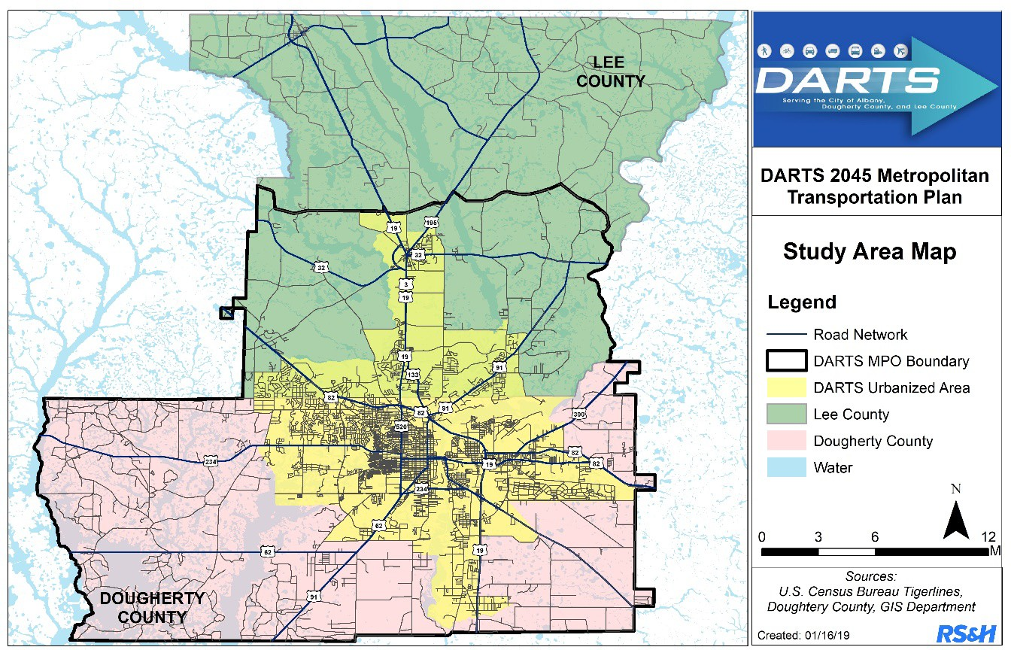

A Metropolitan Planning Organization (MPO) is a federally mandated and federally funded transportation policy making organization that is made up of representatives from local government and governmental transportation authorities. The Dougherty Area Regional Transportation Study (DARTS) was formalized in 1965 as a Continuous, Comprehensive and Cooperative Process as was initially authorized in the Highway Act of 1962.

The purpose of the Dougherty Area Regional Transportation Study (DARTS) is to ensure that federal-aid transportation projects are planned in a continuous, coordinated, and comprehensive manner. The study area of DARTS, the designated Metropolitan Planning Organization (MPO), includes the existing urbanized area for the City of Albany, Dougherty County, the City of Leesburg, the southern half of Lee County, and those areas that are expected to become urbanized over the next 20 years.

The FY 2024-2027 Transportation Improvement Program (TIP) is a prioritized list of funded transportation projects for the DARTS planning area. The TIP is used as an implementation guide by the federal, state, and local agencies. The Federal Highway Administration and the Federal Transit Administration require that the TIP be financially constrained by year and the Georgia Department of Transportation provided the federal and state project status, cost estimates, and available funds for the various projects. The TIP is made up of projects that are listed in the current 2045 Long Range Plan (now known as Metropolitan Transportation Plan or MTP). The TIP addresses present and intermediate transportation needs throughout the metropolitan area. The TIP is updated every four years.

It should be emphasized that the TIP is an expression of intent to implement the identified projects and not a final commitment of funds from any agency. All major transportation projects must appear in an endorsed TIP before they may receive federal funds for implementation. The TIP is based on a reasonable estimate of the amount of federal funds expected to be available to Albany, Dougherty and the southern half of Lee County over the next four fiscal years.

The DARTS Citizens Transportation Committee will review the TIP and forward comments to the Technical Coordinating Committee. The DARTS Technical Coordinating committee is responsible for reviewing the TIP and recommending it for endorsement to the DARTS Policy Committee. Through endorsement by the Policy Committee, this document becomes the official TIP for the Albany Urbanized Area. Project-by-project review and approval by the Georgia Department of Transportation, Federal Highway Administration and Federal Transit Administration is also necessary before federal funds become available. The TIP is a flexible program which may be modified at any time by resolution of the Policy Committee if priorities, area goals or funding level change.

If there are any questions, please contact the Transportation Planner in Planning & Development Services at (229) 302.1843 for assistance.

#### Plan Consistency

Each project in this TIP is taken from the financially constrained project list on the now known as the Metropolitan Transportation Plan or MTP). The project detail sheets that are included in the document list both a DARTS and a GDOT project identification numbers, if available, for cross-reference between the MTP and the TIP.

#### Laws and Regulations

The laws that require MPO’s to develop TIP’s are found in Section 134 of Title 23 and Section 5303 of Title 49 of the United States Code. The rules that govern MPOs are published in the Code of Federal Regulations (CFR’s) at Title 23, Chapter 1, Part 450, Subpart C. Sections 450.324 through 450.330 specifically relate to the development of the TIPs.

The Bipartisan Infrastructure Law (BIL), is the most current law enacted that provides long-term funding certainty for surface transportation, meaning States and local governments can move forward with critical transportation projects. The BIL largely maintains current program structures and funding shares between highway and transit.

The transportation planning process must explicitly address the eleven planning factors included in the Infrastructure Investment and Jobs Act (IIJA) and previously outlined in the Fixing America’s Surface Transportation Act (FAST Act), 23 CFR 450 Subpart C, 23 CFR 420 Subpart A, and 49 CFR Subtitle A, listed below:

**POLICY COMMITTEE VOTING MEMBERS**

##### The Policy Committee is the decision-making body and is represented by elected officials from the member jurisdictions and an official from the Georgia Department of Transportation (GDOT). The committee is responsible for taking into consideration the recommendations from the Citizen’s Advisory Committee and the Technical Coordinating Committee when adopting plans or setting policy.

Billy Breeden Interim Mayor, City of Leesburg

Kermit “Bo” Dorough Mayor, City of Albany

Vacant Dougherty County Administrator

Steven Carter Albany City Manager

Lorenzo Heard Vice Chair, Dougherty County Commission

Vacant Lee County Director of Planning & Engineering

Billy Mathis Lee County Commission

Bob Alexander Leesburg City Manager

Jannine Miller GDOT Director of Planning

Scott Chambers GDOT District 4 Engineer,

* Five (5) voting members are required for a quorum.

###### Non-Voting Members

FHWA Division Administrator

**TECHNICAL COORDINATING COMMITTEE MEMBERS**

##### The Technical Coordinating Committee membership includes staff from the member jurisdictions, various federal, state, and local agencies and associations that have a technical knowledge of transportation or planning. The TCC evaluates transportation plans and projects based on whether they are technically warranted and financially feasible.

Paul Forgey (Chair), Director, Planning & Development Services

Michael Persley Albany Chief of Police

Stacey Rowe Public Works Director (City)

Robert Griffin Interim, Albany Director of Engineering

David Hamilton Transportation Director

Don Gray Albany Facilities Management Director

Chuck Mathis Dougherty County Public Works Director

Jeremy Brown Dougherty County Engineering Manager

Kenneth Johnson Dougherty County Chief of Police

Vacant Lee County Director of Planning & Engineering

Bob Alexander Leesburg Public Works Director & City Manager

Beka Shiver Southwest Georgia Regional Commission

Tanner Anderson Transportation Planner, DARTS MPO

Jason Tolbert Transit Planner, DARTS MPO

Vacant SWGA Regional Airport Superintendent of Operations

Jacqueline Williams GDOT Office of Planning, Transportation Planner,

Jason Willingham GDOT District 4 Preconstruction Engineer,

Ken Breedlove (Vice Chair), Albany Traffic Engineering Manager

Vacant Marine Corps Logistics Base

* Nine (9) voting members required for a quorum.

**TECHNICAL COORDINATING COMMITTEE Non – Voting Members**

Angel Gray Planning Manager

Janine Miller GDOT Office of Planning, Atlanta

Dennis Carter GDOT, District 4 Planning & Programming Coordinator

Brian Langford GDOT, Branch Chief

Joseph Longo U. S. Department of Transportation, FHWA

Billy Merritt Albany Dougherty Planning Commission

Larry McClain Citizens’ Transportation Committee Representative Bob Alexander Leesburg Engineer

**CITIZENS’ TRANSPORTATION COMMITTEE MEMBERS**

##### The Citizens Advisory Committee consists of volunteer members who are interested in transportation issues. They are appointed by their member jurisdictions. The CAC is responsible for ensuring that values and interests of the citizens in Dougherty County, City of Albany, City of Leesburg and a portion of Lee County are taken into consideration in the transportation planning process.

Sonya Johnson (Vice Chair) Dougherty County Appointment

Glenn “Tyler” Harris Dougherty County Appointment

Brent Davis Lee County Appointment

Dr. Peter A. Ngwafu Lee County Appointment

Vacant City of Leesburg Appointment

Larry McClain (Chair) City of Albany Appointment

Bruce Capps City of Albany Appointment

David Gregors City of Albany Appointment

Billy Merritt Albany/Dougherty Planning Commission Appointment

#### MTP Goals and Objectives Comparison to Federal Planning Factors

The Metropolitan Planning program, under the Bipartisan Infrastructure Law (BIL) and Infrastructure Investment and Jobs Act (IIJA) is required to consider the following factors in planning projects, programs and strategies:

* Support the economic vitality of the metropolitan area, especially by enabling global competitiveness, productivity and efficiency;
* Increase the safety of the transportation system for motorized and non- motorized users;
* Increase the security of the transportation system for motorized and non- motorized users;
* Increase the accessibility and mobility of people and for freight;
* Protect and enhance the environment, promote energy conservation, improve the quality of life, and promote consistency between transportation improvements and State and local planned growth and economic development patterns;
* Enhance the integration and connectivity of the transportation system, across and between modes, for people and freight;
* Promote efficient system management and operation;
* Emphasize the preservation of the existing transportation system;
* Improve transportation system resiliency and reliability; Reduce or mitigate stormwater impacts of the surface transportation system;
* Enhance Travel and Tourism.

The Goals of the DARTS MPO address these national Federal Planning Factors and these national Federal Planning Factors and the UPWP directly works toward the incorporation of these goals.

* **Environment and Quality of Life:** Limit and mitigate adverse environmental impacts associated with traffic and transportation system development through facilities design and system management;
* **Safety/Security:** Maintain and improve transportation system safety and security for motorists, pedestrians, and bicyclists.
* **Accessibility and Mobility:** Provide a transportation system that affords sufficient mobility to accommodate the travel demands of Dougherty and South Lee County residents and businesses.
* **Enhanced System Integration and Connectivity:** Provide a multimodal transportation system which offers cost effective alternatives to the automobile, supports efficient freight movement, provides for bicyclists and pedestrians, and encourages continued use and development of air transportation facilities.
* **System Preservation and Maintenance:** Maintain an efficient transportation system within Dougherty and South Lee Counties for residents and businesses.
* **System Management and Operation:** Encourage the implementation of TSM and TDM to reduce traffic congestion and promote low cost solutions of road capacity
* **Reliability and Resiliency:** Improve livability and the quality of the transportation system.
* **Travel and Tourism:** Provide a network that enhances regional accessibility for travel and tourism.
* **Economic Vitality:** Ensure a financially balanced plan and the cost of transportation facilities and services are borne by those who benefit from them.

**Efficiency** - Maintain an efficient transportation system within Dougherty and South Lee County for residents and businesses.

* Efficiently manage DARTS resources and priorities through the Transportation Improvement Program (TIP).
* Develop a transportation network that links DARTS subareas and reduces travel times for area residents and commerce-related trips.
* Plan and improve routes to increase the efficiency of travel and movement of goods and services.
* Use the functional classification system and road standards to guide public investment, determine funding requirements, and establish conditions for approval of private development projects.
* Consider functional Classification in conjunction with land use designations in the preparation and amendment of both counties’ Comprehensive Plans.

**Safety** - Maintain and improve transportation system safety and security for motorists, pedestrians, and bicyclists.

* Review traffic crash data to systematically identify potential safety problems on roadway sections, bridges, and intersections with traffic and develop a list of projects necessary to eliminate deficiencies.
* Prioritize and schedule roadway, bikeway, and sidewalk maintenance expenditures to maintain safe conditions for travel.
* Provide adequate access for emergency service vehicles throughout the system.
* Program and carry out safety improvements through the TIP process.
* Assist Albany Transit in continually improving the safety and efficiency of its active vehicle fleet.

**Mobility** - Provide a transportation system that affords sufficient mobility to accommodate the travel demands of Dougherty and South Lee County residents and businesses.

* Expand the transportation system to accommodate a variety of travel modes and minimize reliance on any single mode.
* Design and manage the transportation system to meet a minimum level of service (LOS) “C” on roadways classified as arterials and collectors.
* Encourage transportation services that accommodate the needs of the transportation disadvantaged.
* Identify roadway sections and intersections operating or projected to operate at less than the area level of service standard and develop a list of projects necessary to eliminate deficiencies.
* Program and implement transportation improvements through the TIP process.

**Environment** - Limit and mitigate adverse environmental impacts associated with traffic and transportation system development through facilities design and system management.

* Develop the DARTS 2045 MTP within the context of the Statewide Transportation Plan (SWTP) to meet federal, state, and local air, water, and noise standards.
* Apprise the EPD, EPA, and Army Corps of Engineers of transportation system development projects at the earliest opportunity to identify project-related environmental issues and to ensure compliance with federal and state air, water, wetland, and noise standards.

**Enhancement** - Improve the livability and quality of transportation system.

* Select projects that will improve the livability and quality of the area’s transportation system.
* Pursue transportation enhancement activity funds for suitable projects.
* Use community land use policies, plans, and ordinances to support historic preservation, limit of outdoor advertising, landscaping and other beautification, and provisions for pedestrian and bicycle facilities.

**Multimodal** - Provide a multimodal transportation system which offers cost-effective alternatives to the automobile, supports efficient freight movement, provides for bicyclists and pedestrians, and encourages continued use and development of air transportation facilities.

###### Freight:

* Designate, prepare, and maintain a map of the Truck Route System.
* Consider freight and truck utilization and impacts on adjacent land uses.
* Proposed transportation projects should consider incorporating features to enhance freight movement and provide adequate design to accommodate large freight vehicles.

###### Transit:

* Work with Albany Transit System to provide continued high-quality transit service to City of Albany residents and businesses and transportation disadvantaged.
* Support transit-oriented development through zoning and land-use policy.
* Design complete streets that include provisions for transit access, including complementary pedestrian and bicycle facilities.
* Provide and maintain safe and comfortable transit amenities (i.e. shelters, benches).

###### Bicycle and Pedestrian:

* Provide for interconnected, direct, and area-wide bicycle and pedestrian circulation system linking recreational areas, schools, shopping areas, employment centers, and adjacent neighborhoods.
* Utilize the Proposed Future Bicycle Corridor Map to guide future bicycle improvements to the Arterial and Collector system.
* Integrate planning of pedestrian and bicycle facilities into development review processes.
* Utilize Regional Bicycle and Pedestrian plan for determining bicycle and pedestrian facility projects.

**Air Transportation** - Continue use and development of air transportation facilities.

* Coordinate Southwest Georgia Regional Airport plans with the State Airport Plan.
* Coordinate with service providers and Southwest Georgia Regional Airport to plan for appropriate future expansion.
* Review land use policies to examine compatibility of airport and complementary uses with adjacent development.

**Transportation System Management (TSM) and Transportation Demand Management (TDM)** - Encourage implementation of TSM and TDM to reduce traffic congestion and promote low-cost solutions for road capacity.

* Support TSM alternatives such as access management and Intelligent Transportation System (ITS).
* Support formal development of a DARTS-regional TDM program.
* Incorporate into the land use planning and permitting process provisions for review of the impact of specific developments on the transportation network.

**Financial** - Provide financially balanced transportation documents.

* Prepare estimates of the amount of funding that will be available from federal, state, and local sources.
* Prepare cost estimates for capital projects and maintenance of the transportation system.

**Equity** - Ensure the cost of transportation facilities and services are borne by those who benefit from them.

* Develop equitable financing mechanisms for existing system maintenance and improvement, and through the development review process, require improvements necessary to accommodate future growth.
* Provide transportation services and facilities in a timely manner according to funding capabilities.

**System Maintenance** - Maintain and preserve the existing transportation system.

* Determine the backlog of deferred maintenance and the annual maintenance requirements of the area roadway system.
* Determine area-wide roadway system reconstruction needs.
* Prioritize and carry out maintenance and reconstruction activities through the annual maintenance and reconstruction program process.

*When projects are planned, designed, or constructed evaluate the life-cycle costs and make appropriate decisions at each step to ensure that projects that are built are as maintenance free as possible.*

#### Planning Factors (23 CFR 450.306)

The UPWP is developed to provide comprehensive, cooperative, and continuing transportation planning The IIJA requires that the metropolitan planning process consider and analyze the following ten factors for each planning activity. These factors continue to influence the program of the UPWP. The ten planning activity factors with associated goals and objectives are show below and are integrated into the UPWP task elements.

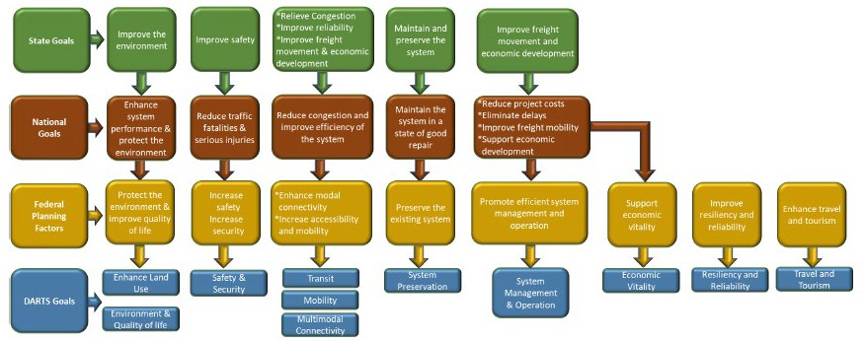

#### Format

The TIP document contains the following spreadsheets and detail pages showing a list of projects and the funding dollars:

* FY 2024-2027 Projects - this spreadsheet contains a list of projects along with the dollar amounts scheduled for the fiscal years 2024-2027.
* FY 2024-2027 Lump Sum Funding Categories - this spreadsheet reflects available funding dollars for the DARTS area in lump sum categories for the fiscal years 2021-2024.
* FY 2024-2027 Dougherty Area Transit Funding - this spreadsheet contains the Dougherty Area Transit funding categories along with the dollar amounts for the fiscal years 2024- 2027.
* Project Detail Sheets 2024-2027 – these worksheets supply more detail on these projects that are funded from 2024-2027. Here you will also find project definitions page to explain various items that are not self-explanatory. It also includes project worksheets that supply more detail on these projects.
* A detailed breakdown of the various transit funding categories.
* A narrative on lump sum funding.
* A list of all the MPO authorized projects.
* Appendix
  + Provides a list of definitions, abbreviations, funding and phase codes, and acronyms used within the text of this TIP.
  + Public comments received on the TIP.
  + Provides a copy of the Self Certification required of all MPO’s.
  + Provides a copy of the amendment process for the TIP.

#### Project Evaluation

In order to determine the priority of the capital projects the MPO designed a prioritization framework to address the need for each project as objectively as possible. Using the Goals and Objectives from our Metropolitan Transportation Plan, projects were ranked for the applicability in ten categories:

* Capacity/Delay Reduction – Ability of the project to address and reduce congestion.
* Safety – Ability of the project to address transportation safety.
* Constructability – Relative ease of the project to be constructed.
* Environmental – Reflects the number of likely environmental impacts the project will encounter.
* Access to Major Generators – Reflects the projects ability to access major land use generators in the DARTS region.
* Land Use Coordination – Reflects the project’s compatibility with land use plans.
* Regional Connectivity – Reflects the project’s ability to connect more effectively areas within the DARTS region and/or ability to connect the region more effectively with areas outside of the region.
* Multimodal Friendly – Reflects the project’s ability to address multimodal transportation needs.
* Local Support – Reflects the project’s relative support as determined through public and stakeholder involvement.
* BIL – Reflects the project’s compatibility with the performance goals outlined.

Each project was ranked with a score between 1 (poor) and 10 excellent with a score in the middle (4, 5, 6) reflecting a neutral position in these nine categories. The scores were first tallied through a combination of technical and qualitative analyses. Following the initial scoring, the prioritization results were vetted through the technical committee of DARTS.

### Performance Assessment Tool

The project performance assessment and prioritization tool was built using a GIS analysis in combination with a spreadsheet analysis. This tool is customizable and adaptable to the specific MPO. The parameters for assessing each project were identified within the framework of the DARTS goals and objectives; data from available sources such as GDOT and local governments were utilized in the tool and the assessment modules. The GDOT data included traffic counts and truck counts/truck percent from the Traffic Analysis and Data Application (TADA), formerly known as GEOCOUNTS. Crash data was obtained through the GDOT Georgia Electronic Accident Reporting System (GEARS) and entered, and then the crash rates of crashes per 100 million vehicle miles of travel were developed from the raw crash numbers to normalize the numbers. The actual crash numbers for the bicycle and pedestrian modes were used. Crash data from the most recent five years was utilized and included data from the years 2014 – 2018. Local government information included existing and future land uses, existing and planned transit routes, and regional multimodal connections. Local visitors bureaus and GIS departments were used to identify tourist attractions, historic sites, and natural resources; state databases were also utilized to provide additional information. The performance measures included both data-based quantitative metrics and a qualitative assessment. The qualitative assessment included the GIS analysis of access to freight generators and attractors, multimodal facilities, and tourist attractions, as well as impacts to community and environmental resources. Through the GIS analysis, each project was screened and rated as “yes” it meets the criteria, translating to a numeric input of 1.0; “no” the project does not meet the criteria, translating to a numeric input of 0; , or the project “somewhat” meets the criteria, translating to a numeric input of 0.5. Each project was tested based on the following performance measures:

• Average Annual Daily Traffic

• Average Annual Daily Truck Traffic/Truck Percent

• Volume to Capacity Ratio

• Level of Service

• Number of Crashes

• Crash Rate per 100 Million Vehicle Miles of Travel

• Crash Fatalities

• Crash Injuries

• Support of Freight Movement

o Access to Existing and Future Freight Generators and Attractors

• Multimodal Inputs

o Access to Existing and Planned Bicycle and Pedestrian Facilities

o Access to Existing and Planned Transit Service

o Support of Regional Multimodal Connections

o Access to Airport

• Support of Access to Tourism Attractors

• Impacts to Historic Resources

• Impacts to Environmental Resources

The tool is built on the base information addressing each of these performance measures. The first step in the development of the tool was the incorporation of these data in worksheets that feed into the main assessment tool and are updatable should the need arise to add projects and/or update data for existing projects. The graphics below displays an example of the worksheet tabs within the tool where the base data is located and then the content of the safety data worksheet to provide an example of how the base data for each performance measure is included.

The next step in the tool is the raw project assessment without the application of additional prioritization factors. This assessment provided the information needed to identify how the project would address any identified issues. An example of the assessment is shown in the figure below, with areas of most concern highlighted in red transitioning to yellow for those areas of lesser concern. The figure does not display all of the metrics, but is intended to be a graphical representation of the assessment results.

The next step in the tool is the application of the priority weighting for each of the established goals. These goals were identified through the stakeholder and public participation process, staff input, and input from the Technical Subcommittee. The priority ranking was established using the following:

• Results from the public survey

• Results from the Stakeholder Committee

• Results from staff review

The results of these rankings were averaged to reach the final weighing applied in the project prioritization process. These priority rankings were included as an input on a separate worksheet and then applied to the based performance assessment for each project.

Similar to the base project data, the priority rankings are also updatable should priorities change and can be applied to reassess projects, as necessary. The final step in the performance tool is the application of the prioritization factors to the base project assessment.

This prioritized ranking process utilized the results from the base assessment, applied the priority ranking, and resulted in the prioritized project list, which displays the total ranking score, as well as the score for each of the assessment criteria. Those projects incorporated in the Transportation Improvement Program were not assessed within the tool. The graphic below displays a representation of the project prioritization process and the total Table
project scores.

The final step in the tool is the project performance dashboard. This dashboard displays how each project performs in meeting the goals established by DARTS, as well as the federal planning factors, and the national and state goals.

With the spreadsheet format and the updatable components, this tool can be used to monitor and assess how the project performed in meeting the goals and objectives after implementation. With the completion of a project, the post-implementation data can be collected and input into the tool, which will provide the updated performance summary for the project. This feature enables the MPO to analyze and clearly understand how the project performed in meeting the established goals

***FINANCIAL PLAN***

**Financial Assessment**

In order to develop a financially feasible, or cost constrained plan, which is a federal requirement, a detailed financial analysis must be undertaken. Revenues for funding transportation projects must be identified and balanced with the project costs over the planning horizon. Both the revenue and cost estimates are developed for the plan’s base year, and then project costs are inflated to Year of Expenditure (YOE). DARTS and GDOT coordinated to determine the annual inflation rate used to develop the YOE costs, which is a two percent annual inflation.

Revenue estimates include funding from all potential sources. Through the cooperative partnership, GDOT provided the revenues anticipated to be available for DARTS projects over the planning horizon. The revenue estimates for projects is $74,740,700; estimates over the planning horizon for maintenance total $19,501,488 for a total revenue estimate of $94,242,188. The revenue projections, by year from 2025 to 2030, are shown in table below:

|  |  |  |  |
| --- | --- | --- | --- |
| **Year** | **Project Estimate** | **Maintenance Estimate** | **Total Estimate** |
| **2024** | $12,028,692 | $3,138,550 | ***$14,575,421*** |
| **2025** | $12,148,979 | $3,169,935 | ***$15,318,914*** |
| **2026** | $12,270,468 | $3,201,634 | ***$15,472,102*** |
| **2027** | $12,393,173 | $3,233,651 | ***$15,626,824*** |
| **2028** | $12,517,105 | $3,265,987 | ***$15,783,092*** |
| **2029** | $12,642,276 | $3,298,647 | ***$15,940,923*** |
| **2030** | $12,768,699 | $3,331,634 | ***$16,100,333*** |

Dougherty and Lee Counties passed sales tax initiatives dedicated to transportation. In the Spring of 2019, Dougherty County and the City of Albany, along with neighboring Worth County, passed a TSPLOST with the one cent sales tax expected to generate approximately $80 million over the five year period. The City of Albany and Dougherty County will vote to renew TSPLOST in November 2023.These additional funds are targeted for road construction, paving/maintenance, and bridge improvements.

In November 2022 Lee County passed TSPLOST, with the one cent sales tax anticipated to generate approximately $23 million. The county plans to focus on maintenance of the county road network; the County maintains approximately 200 miles of paved roads and 200 miles of unpaved roads.

With the development of the revenue estimates, the project costs were also estimated. As noted earlier, these project costs are developed for the base year of the plan and then inflated annually to the Year of Expenditure. These cost estimates utilized sources such as the GDOT Cost Estimation Tool, as well as information and input from local staff. In addition, the cost estimates were compared to similar programmed projects as a check. The cost estimates included all engineering phases of Preliminary Engineering (PE), Right of Way / Utilities (ROW/UTIL) , and Construction (CST). The cost estimates for these distinct phases were added to obtain the total project cost. The project prioritization process provided the needed information to develop the cost feasible, or cost constrained, project list when comparing the available revenues with the project costs.

### ANTICIPATED REVENUE

|  |  |  |  |  |  |  |  |  |
| --- | --- | --- | --- | --- | --- | --- | --- | --- |
| **ALBANY** | | | | | | | |  |
| **TOTAL EXPECTED HIGHWAY & TRANSIT** | | | | | | | |  |
| **STIP FUNDS (MATCHED)** | | | | | | | |  |
| **FY 2024 - FY 2027** | | | | | | | |  |
| **FUND** | **CODE** | **LUMP DESCRIPTION** | **2024** | **2025** | **2026** | **2027** | **TOTAL** | |
| STBG | Y236 |  | $ - | $ - | $ - | $ 100,000 | $ 100,000 | |
| Carbon | Y606 |  | $ 332,104 | $ 551,336 | $ 551,336 | $ 551,336 | $ 1,986,111 | |
| PROTECT | Y800 |  | $ - | $ - | $ - | $ 17,650,340 | $ 17,650,340 | |
| Other | L490 |  | $ 45,000 | $ 45,000 | $ 45,000 | $ 45,000 | $ 180,000 | |
| Transit | 5303 |  | $ 100,202 | $ 100,202 | $ 100,202 | $ 100,202 | $ 400,808 | |
| Transit | 5307 |  | $ 2,660,252 | $ 7,931,744 | $ 11,125,864 | $ 3,965,872 | $ 25,683,732 | |
| Transit | 5311 |  | $ 1,887,079 | $ - | $ - | $ - | $ 1,887,079 | |
| NHPP | Y001 | LIGHTING | $ 10,000 | $ 10,000 | $ 10,000 | $ 10,000 | $ 40,000 | |
| NHPP/STBG | Various | BRIDGE MAINTENANCE | $ 445,000 | $ 445,000 | $ 445,000 | $ 445,000 | $ 1,780,000 | |
| NHPP/STBG | Various | ROAD MAINTENANCE | $ 2,768,000 | $ 2,472,000 | $ 2,472,000 | $ 2,472,000 | $ 10,184,000 | |
| STBG | Y240 | LOW IMPACT BRIDGES | $ 208,000 | $ 208,000 | $ 208,000 | $ 208,000 | $ 832,000 | |
| STBG | Y240 | OPERATIONS | $ 119,000 | $ 119,000 | $ 119,000 | $ 119,000 | $ 476,000 | |
| STBG | Y240 | TRAF CONTROL DEVICES | $ 297,000 | $ 297,000 | $ 297,000 | $ 297,000 | $ 1,188,000 | |
| STBG | Y240 | RW PROTECTIVE BUY | $ 15,000 | $ 15,000 | $ 15,000 | $ 15,000 | $ 60,000 | |
| HSIP | YS30 | SAFETY | $ 989,000 | $ 989,000 | $ 989,000 | $ 989,000 | $ 3,956,000 | |
| RRX | YS40 | RAILROAD CROSSINGS | $ 114,000 | $ 114,000 | $ 114,000 | $ 114,000 | $ 456,000 | |
| **TOTAL** | | | **$ 9,989,637** | **$ 13,297,282** | **$ 16,491,402** | **$ 27,081,750** | **$ 66,860,070** | |



Dougherty Area Regional Transportation Study (DARTS)

Anticipated Federal Expenditures

|  |  |  |  |  |  |  |  |  |  |  |  |  |  |  |  |  |  |  |  |
| --- | --- | --- | --- | --- | --- | --- | --- | --- | --- | --- | --- | --- | --- | --- | --- | --- | --- | --- | --- |
| **STP FUNDS L490** |  |  |  |  |  |  |  |  |  |  |  |  |  |  |  | |  |  |  |
|  |  |  | **TIP** | | | | | | | | | | | | | | | | | |
|  |  |  | **FY 2024** | | | | **FY 2025** | | | | **FY 2026** | | | | | **FY 2027** | | | | |
| **PI#** | **Project Description** | **TIP Page #** | **PE** | **ROW** | **UTL** | **CST** | **PE** | **ROW** | **UTL** | **CST** | **PE** | **ROW** | **UTL** | **CST** | **PE** | | **ROW** | **UTL** | **CST** |
| 0013495 | SUMMER TRANSPORTATION INSTITUTE @ ALBANY UNIVERSITY | 32 | $45,000 |  |  |  |  |  |  |  |  |  |  |  |  | |  |  |  |
| 0013496 | SUMMER TRANSPORTATION INSTITUTE @ ALBANY UNIVERSITY | 33 |  |  |  |  | $45,000 |  |  |  |  |  |  |  |  | |  |  |  |
| 0013496 | SUMMER TRANSPORTATION INSTITUTE @ ALBANY UNIVERSITY | 34 |  |  |  |  |  |  |  |  | $45,000 |  |  |  | $45,000 | |  |  |  |
| 0013496 | SUMMER TRANSPORTATION INSTITUTE @ ALBANY UNIVERSITY | 35 |  |  |  |  |  |  |  |  |  |  |  |  |  | |  |  |  |
| **Subtotal L490 COST** | |  |  |  |  | **$** | **$ -** | **$ -** | **$ -** | **$ -** | **$ -** | **$ -** | **$ -** | **$ -** | **$ -** | | **$ -** | **$ -** | **$ -** |
| **Total L490 COST** | |  | **$45,000** |  |  |  | **$45,000** |  |  | **$ -** | **$45,000** |  |  | **$ -** | **$45,000** | |  |  | **$ -** |
| **AVAILABLE L490 FUND** | |  | **$45,000** |  |  | **$** | **$45,000** |  |  | **$ -** | **$45,000** |  |  | **$ -** | **$45,000** | |  |  | **$ -** |

|  |  |  |  |  |  |  |  |  |  |  |  |  |  |  |  |  |  |  |  |  |
| --- | --- | --- | --- | --- | --- | --- | --- | --- | --- | --- | --- | --- | --- | --- | --- | --- | --- | --- | --- | --- |
| **STP FUNDS**  **Y236** |  |  | **TIP** | | | | | | | | | | | | | | | | | |
|  |  |  | **FY 2024** | | | | **FY 2025** | | | | **FY 2026** | | | | | **FY 2027** | | | | |
| **PI#** | **Project Description** | **TIP Page #** | **PE** | **ROW** | **UTL** | **CST** | **PE** | **ROW** | **UTL** | **CST** | **PE** | **ROW** | **UTL** | **CST** | **PE** | | **ROW** | **UTL** | **CST** |
| _0013583 | SR 234 SBL @ GA-FL RAILNET INC ALBANY – SE SECTION | 38 |  |  |  |  |  |  |  |  |  |  |  |  | $100,000 | |  |  |  |
| _0013992 | SR 520BU @ FLINT RIVER IN ALBANY | 37 |  |  |  |  |  |  |  |  |  |  |  |  |  | |  | $6,613 |  |
| _0013992 | SR 520BU @ FLINT RIVER IN ALBANY | 37 |  |  |  |  |  |  |  |  |  |  |  |  |  | |  |  | $17,643,727 |
| **Subtotal Y236 COST** | |  |  | **$ -** | **$ -** | **$ -** | **$ -** | **$ -** | **$ -** | **$**  **-** | **$ -** | **$**  **-** | **$ -** | **$ -** | **$100,000** | | **$ -** | **$6,613** | **$17,643,727** |
| **Total Y236 COST** | |  |  |  |  |  |  |  |  |  |  |  |  |  | **$100,000** | |  | **$6,613** | **$17,643,727** |
| **AVAILABLE Y236 FUND** | |  |  |  |  |  |  |  |  |  |  |  |  |  | **$17,750,340** | |  | **$17,750,340** | **$17,750,340** |

### ANTICIPATED EXPENDITURES

(Overall Project Listing for FY 2024 – 202

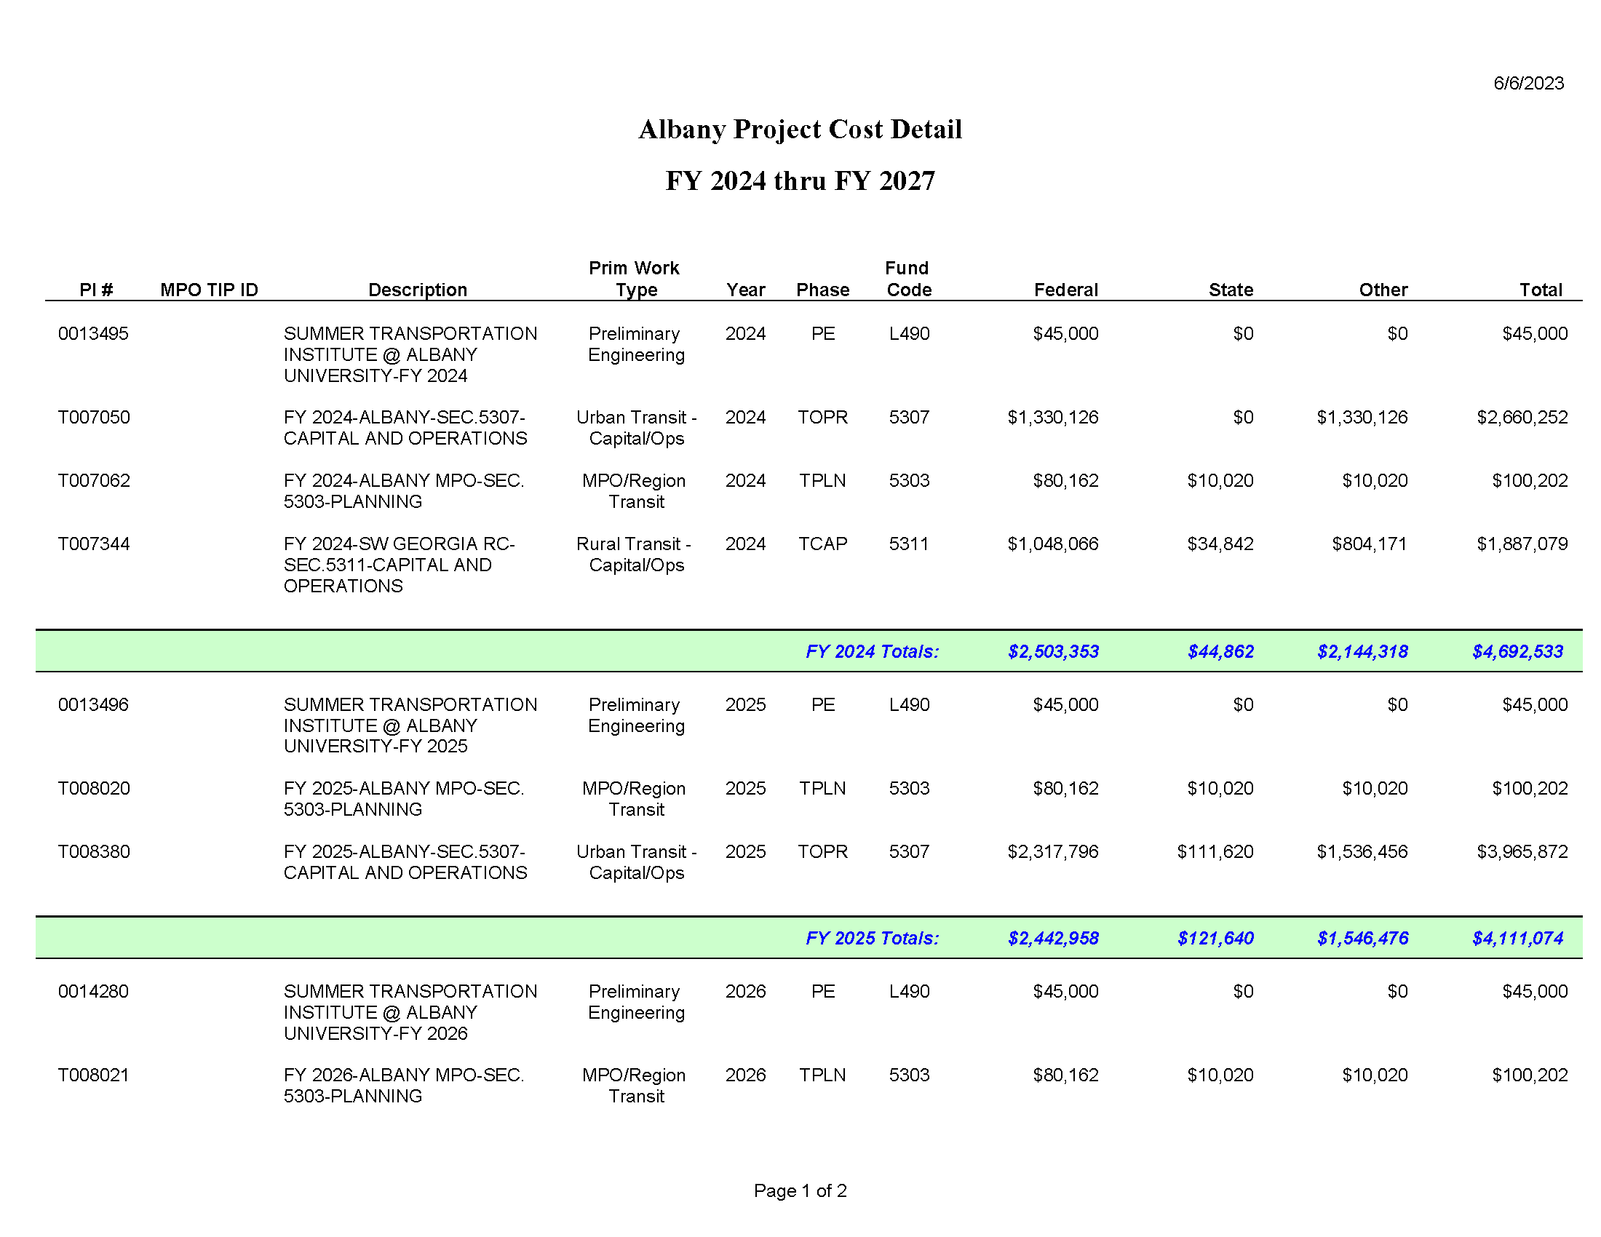

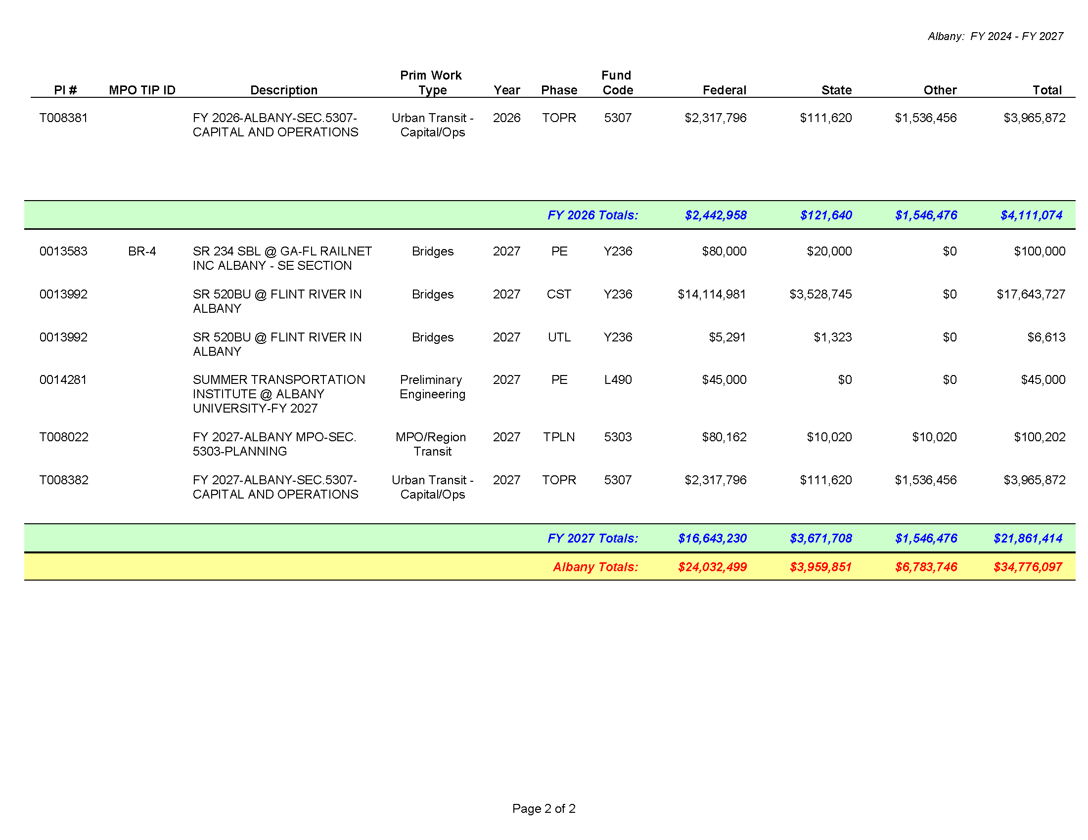

***DARTS FY24-27***

***PROJECT OVERVIEW***

|  |  |  |  |  |  |  |
| --- | --- | --- | --- | --- | --- | --- |
| **SUMMER TRANSPORTATION INSTITUTE @ ALBANY UNIVERSITY**  PROJECT DESCRIPTION: Program – GDOT Partnership with Albany State University (ASU) to provide summer educational opportunities to local high school students in Albany/Dougherty County. | | | | | | P.I.#: 0013495 |
| TIP #: |
| COUNTY: Dougherty |
| PROJ #: |
| FUND: L490 |
| GDOT DISTRICT: 4th |
| TRAFFIC VOL 2021 AADT: | | | | 2045: | | CONG DISTRICT: 2nd |
| NO. OF LANES EXISTING: | | | | PLANNED: | | RC: SWGA RC |
| LOCAL ROAD #: | | STATE/US ROAD #: | | | | LENGTH (MI): |
| COMMENTS/REMARKS: National Summer Transportation Institute For Secondary School Students | | | | | | |
| **PROJECT PHASE** | **$ SOURCE** | **FY 2024** | **FY 2025** | **FY 2026** | **FY 2027** | **Total** |
| **PRELIM ENGR.** | Federal | $45,000 |  |  |  | $45,000 |
| **RIGHT-OF-WAY** |  |  |  |  |  |  |
| **UTILITIES** |  |  |  |  |  |  |
| **CONSTRUCTION** |  |  |  |  |  |  |
| **PROJECT COST** |  |  |  |  |  |  |
| **FEDERAL COST** |  | $45,000 |  |  |  | $45,000 |
| **STATE COST** |  |  |  |  |  |  |
| **LOCAL COST** |  |  |  |  |  |  |

|  |  |  |  |  |  |  |
| --- | --- | --- | --- | --- | --- | --- |
| **SUMMER TRANSPORTATION INSTITUTE @ ALBANY UNIVERSITY**  PROJECT DESCRIPTION: Program – GDOT Partnership with Albany State University (ASU) to provide summer educational opportunities to local high school students in Albany/Dougherty County. | | | | | | P.I.#: 0013496 |
| TIP #: |
| COUNTY: Dougherty |
| PROJ #: |
| FUND: L490 |
| GDOT DISTRICT: 4th |
| TRAFFIC VOL 2021 AADT: | | | | 2045: | | CONG DISTRICT: 2nd |
| NO. OF LANES EXISTING: | | | | PLANNED: | | RC: SWGA RC |
| LOCAL ROAD #: | | STATE/US ROAD #: | | | | LENGTH (MI): |
| COMMENTS/REMARKS: National Summer Transportation Institute For Secondary School Students | | | | | | |
| **PROJECT PHASE** | **$ SOURCE** | **FY 2024** | **FY 2025** | **FY 2026** | **FY 2027** | **Total** |
| **PRELIM ENGR.** | Federal |  | $45,000 |  |  | $45,000 |
| **RIGHT-OF-WAY** |  |  |  |  |  |  |
| **UTILITIES** |  |  |  |  |  |  |
| **CONSTRUCTION** |  |  |  |  |  |  |
| **PROJECT COST** |  |  |  |  |  |  |
| **FEDERAL COST** |  |  | $45,000 |  |  | $45,000 |
| **STATE COST** |  |  |  |  |  |  |
| **LOCAL COST** |  |  |  |  |  |  |

|  |  |  |  |  |  |  |
| --- | --- | --- | --- | --- | --- | --- |
| **SUMMER TRANSPORTATION INSTITUTE @ ALBANY UNIVERSITY**  PROJECT DESCRIPTION: Program – GDOT Partnership with Albany State University (ASU) to provide summer educational opportunities to local high school students in Albany/Dougherty County. | | | | | | P.I.#: 0014280 |
| TIP #: |
| COUNTY: Dougherty |
| PROJ #: |
| FUND: L490 |
| GDOT DISTRICT: 4th |
| TRAFFIC VOL 2021 AADT: | | | | 2045: | | CONG DISTRICT: 2nd |
| NO. OF LANES EXISTING: | | | | PLANNED: | | RC: SWGA RC |
| LOCAL ROAD #: | | STATE/US ROAD #: | | | | LENGTH (MI): |
| COMMENTS/REMARKS: National Summer Transportation Institute For Secondary School Students | | | | | | |
| **PROJECT PHASE** | **$ SOURCE** | **FY 2024** | **FY 2025** | **FY 2026** | **FY 2027** | **Total** |
| **PRELIM ENGR.** | Federal |  |  | $45,000 |  | $45,000 |
| **RIGHT-OF-WAY** |  |  |  |  |  |  |
| **UTILITIES** |  |  |  |  |  |  |
| **CONSTRUCTION** |  |  |  |  |  |  |
| **PROJECT COST** |  |  |  |  |  |  |
| **FEDERAL COST** |  |  |  | $45,000 |  | $45,000 |
| **STATE COST** |  |  |  |  |  |  |
| **LOCAL COST** |  |  |  |  |  |  |

|  |  |  |  |  |  |  |
| --- | --- | --- | --- | --- | --- | --- |
| **SUMMER TRANSPORTATION INSTITUTE @ ALBANY UNIVERSITY**  PROJECT DESCRIPTION: Program – GDOT Partnership with Albany State University (ASU) to provide summer educational opportunities to local high school students in Albany/Dougherty County. | | | | | | P.I.#: 0014281 |
| TIP #: |
| COUNTY: Dougherty |
| PROJ #: |
| FUND: L490 |
| GDOT DISTRICT: 4th |
| TRAFFIC VOL 2021 AADT: | | | | 2045: | | CONG DISTRICT: 2nd |
| NO. OF LANES EXISTING: | | | | PLANNED: | | RC: SWGA RC |
| LOCAL ROAD #: | | STATE/US ROAD #: | | | | LENGTH (MI): |
| COMMENTS/REMARKS: National Summer Transportation Institute For Secondary School Students | | | | | | |
| **PROJECT PHASE** | **$ SOURCE** | **FY 2024** | **FY 2025** | **FY 2026** | **FY 2027** | **Total** |
| **PRELIM ENGR.** | Federal |  |  |  | $45,000 | $45,000 |
| **RIGHT-OF-WAY** |  |  |  |  |  |  |
| **UTILITIES** |  |  |  |  |  |  |
| **CONSTRUCTION** |  |  |  |  |  |  |
| **PROJECT COST** |  |  |  |  |  |  |
| **FEDERAL COST** |  |  |  |  | $45,000 | $45,000 |
| **STATE COST** |  |  |  |  |  |  |
| **LOCAL COST** |  |  |  |  |  |  |

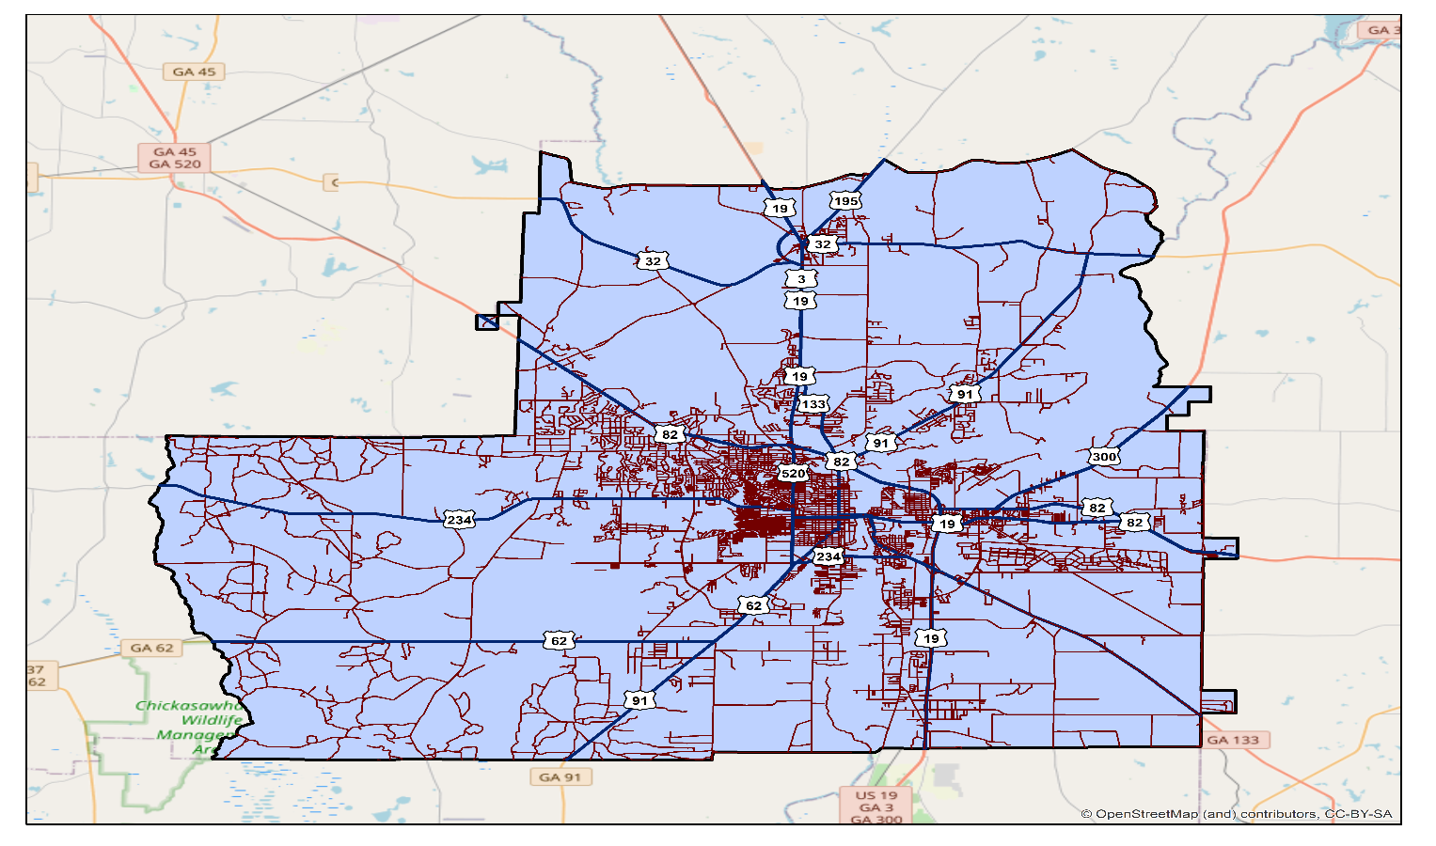

|  |  |  |  |  |  |  |
| --- | --- | --- | --- | --- | --- | --- |
| **SR 520 BU @ FLINT RIVER IN ALBANY**  PROJECT DESCRIPTION: Bridge - This project, with an approximate total length of 0.30 miles, will replace the existing bridge on SR 520BU/US 82BU over the Flint River in Albany, Georgia with a new bridge consisting of 4, 12ft lanes, 2ft gutters, and a 5.5ft sidewalk on the north side of the bridge and 12.0ft barrier separated, shared use path on the south side of the bridge. The existing roadway will be detoured to construct the proposed bridge in the same location as the existing bridge. The existing westbound right turn lane and left turn lane will be lengthened to provide a longer taper and queue length. | | | | | | P.I.#: 0013992 |
| TIP #: |
| COUNTY: Dougherty |
| PROJ #: |
| FUND: Y236 |
| GDOT DISTRICT: 4th |
| TRAFFIC VOL 2021 AADT: 23,500 | | | | 2045: | | CONG DISTRICT: 2nd |
| NO. OF LANES EXISTING: 4 | | | | PLANNED: 4 | | RC: SWGA RC |
| LOCAL ROAD #: | | STATE/US ROAD #: SR 520 BU | | | | LENGTH (MI): 0.30 |
| COMMENTS/REMARKS: | | | | | | |
| **PROJECT PHASE** | **$ SOURCE** | **FY 2024** | **FY 2025** | **FY 2026** | **FY 2027** | **Total** |
| **PRELIM ENGR.** |  |  |  |  |  |  |
| **RIGHT-OF-WAY** |  |  |  |  |  |  |
| **UTILITIES** | Fed/State |  |  |  | $6,613.00 | $6,613.00 |
| **CONSTRUCTION** | Fed/State |  |  |  | $17,643,727 | $17,643,727 |
| **PROJECT COST** |  |  |  |  |  |  |
| **FEDERAL COST** |  |  |  |  | $14,120,272 | $14,120,272 |
| **STATE COST** |  |  |  |  | $3,530,068 | $3,530,068 |
| **LOCAL COST** |  |  |  |  |  |  |

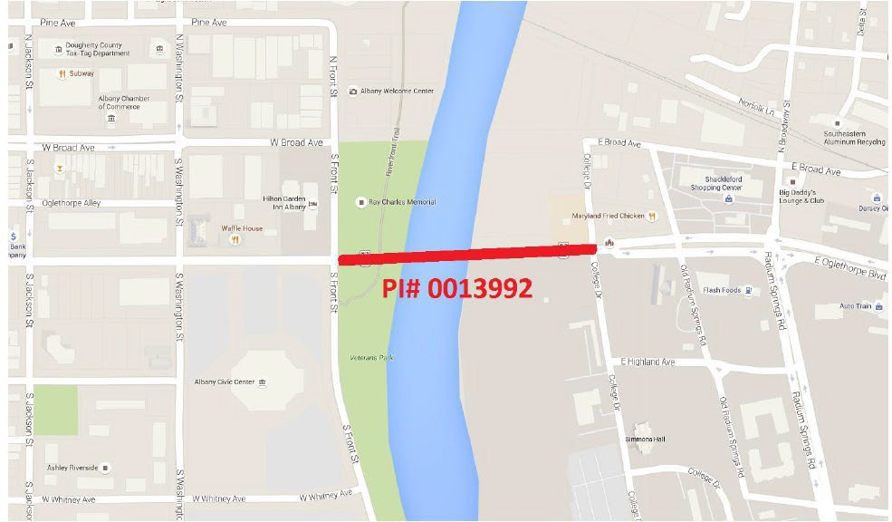

|  |  |  |  |  |  |  |
| --- | --- | --- | --- | --- | --- | --- |
| **SR 234 SBL @ GA-FL RAILNET INC ALBANY - SE SECTION**  PROJECT DESCRIPTION: Bridge – Replacement – Approximate length of 0.40 miles, will replace the existing bridge on SR 234. | | | | | | P.I.#: 0013583 |
| TIP #: BR-4 |
| COUNTY: Dougherty |
| PROJ #: |
| FUND: Y236 |
| GDOT DISTRICT: 4th |
| TRAFFIC VOL 2021 AADT: 16,500 | | | | 2045: | | CONG DISTRICT: 2nd |
| NO. OF LANES EXISTING: 4 | | | | PLANNED: 4 | | RC: SWGA RC |
| LOCAL ROAD #: | | STATE/US ROAD #: SR 234 | | | | LENGTH (MI): 0.40 |
| COMMENTS/REMARKS: | | | | | | |
| **PROJECT PHASE** | **$ SOURCE** | **FY 2024** | **FY 2025** | **FY 2026** | **FY 2027** | **Total** |
| **PRELIM ENGR.** | Fed/State |  |  |  | $100,000 | $100,000 |
| **RIGHT-OF-WAY** |  |  |  |  |  |  |
| **CONSTRUCTION** |  |  |  |  |  |  |
| **PROJECT COST** |  |  |  |  |  |  |
| **FEDERAL COST** |  |  |  |  | $80,000 | $80,000 |
| **STATE COST** |  |  |  |  | $20,000 | $20,000 |
| **LOCAL COST** |  |  |  |  |  |  |

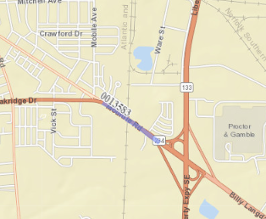

### 

### PUBLIC TRANSIT

***(FY 2024-2027) Albany Transit Asset Management***

1. Introduction to TAM

With the adoption by Congress of the Moving Ahead for Progress in the 21st Century (MAP-21) Act, transit providers like Albany Transit System were required to establish plans for maintaining their assets in what the law defines as a State of Good Repair (SGR). 49 CFR part 625 defines the term “State of Good Repair” as “the condition in which a capital asset is able to operate at a full level of performance”. Transit Asset Management plans inventory assets, assess their condition, and set targets for their replacement such that a majority of the assets are in a State of Good Repair.

1. Adoption of State of Georgia Group Transit Asset Management Plan

The federal law distinguishes between large and small transit providers and places less requirements upon the smaller operators. Albany Transit falls within the latter category and is allowed to join with other small providers to form a Group Transit Asset Management Plan. The State of Georgia sponsors this group plan which includes 92 participants statewide. Albany Transit ratified the Georgia Department of Transportation Group Transit Asset Management Plan in September 2018.

Transit Asset Management plans for small transit providers have four distinct elements:

* + Inventory of Capital Assets
  + Condition Assessment of the capital assets
  + Description of Decision Support Tools which define the needed amount of capital investment and determine when assets are to be replaced
  + Prioritized list of investments

The rest of this document will detail these items pertaining to the Albany Transit System.

1. Existing Inventory

The Albany Transit System receives state funding from two sources: Department of Transportation Section 5307 Small Urban Transportation grants and 5339 Bus and Bus Facility funds. The system operates a fleet of 18 fixed route guideway vehicles, 6 ADA Para Transit vehicles, and (soon) 2 ADA electric vans funded through the 5307 and 5339 programs. The paratransit service is provided on a demand-response basis, meaning that riders must call in advance for appointments to schedule trips from point of origin to point of destination. The system also maintains the Albany Transit Administrative Office and the Albany Transportation Center. The maintenance operation is currently supported by the City of Albany Fleet Management Department.

1. Targets and explanation

Section 4.2 of the Georgia Group TAM Plan establishes targets for the operation of transit vehicles, equipment and facilities at each of the participating agencies. These targets and current levels are posted in the plan as follows:

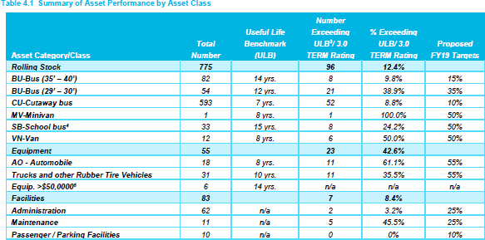

The Useful Life Benchmark is the rated number of years a particular type of vehicle can be expected to safely and reliably operate without major failure. The performance measure for facilities is the percentage of facilities within an asset class that are rated below condition 3.0 on the Transit Economic Requirements Model (TERM) scale. The TERM scale takes into account the type of asset, its age, its condition, funding source, and FY 18 replacement cost to rate facilities. Those which fall below a score of 3.0 on the scale are deemed in need of improvement.

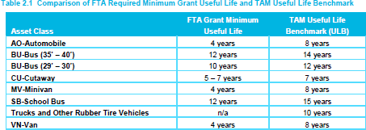

Albany Transit’s fleet currently includes three 30’ft fixed route buses with a useful life benchmark of 10 years, twelve 35’ft fixed route buses with a useful life benchmark of 12-14 years. Six Cutaway buses that the system uses has a 5–7-year useful life benchmark, and 2 incoming electric ADA vans that have a 4–8-year useful life benchmark. Albany Transit System has agreed to adhere to the targets recommended by the state, as our inventory is a part of the group plan.

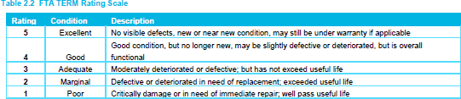

All facilities operated or shared by Albany Transit System meet and exceed the 3.0 scoring threshold used in the TERM scale.

1. Decision Tool used

The Georgia Group TAM Plan uses the Federal Transit Administration’s Transit Economic Requirements Model Analysis Tool, referred as “TERM Lite” in the document, to analyze the condition of vehicles, equipment and facilities and help guide decisions regarding priorities for repair and replacement. Factors used in the decision matrix included condition of the asset and available funds for transit operations from federal, state and local resources.

1. Investment prioritization as a result of the tool

As a result of the TERM Lite analysis, five paratransit vehicles are scheduled to be purchased in the next three years for an approximate investment of $1,000,000. The expected source of funding for these purchases is the Section 5339 Urban Transit Program and 5339 Bus and Bus Facility. The funding sources to be expected from the Federal Transit Administration will be provided through the projects identified in the following table. Albany Transit expenditures under the FY 2024-2027 TIP meet all TAM targets

|  |  |  |  |  |  |
| --- | --- | --- | --- | --- | --- |
| **CAPITAL SCHEDULE FOR ALBANY TRANSIT SYSTEM** | | | | | |
| Section 5307 | | | | | |
|  | 7.1.23-6.30.24 | 7.1.24-6.30.25 | 7.1.25-6.30.26 | 7.1.26-6.30.27 |  |
| **DESCRIPTION** | **FY24** | **FY25** | **FY26** | **FY 27** | **TOTAL** |
| **STIP #** | **T007050** | **T008380** | **T00838** | **T008382** |  |
| Purchase CNG Fixed Route 35' Bus | $0 | $0 | $0 | $0 | $0 |
| Purchase CNG Paratransit Bus (6) | $0 | $1,000,000 | $200,000 | $0 | $1,200,000 |
| Preventive Maintenance | $920,000 | $1,000,000 | $1,000,000 | $1,000,000 | $3,920,000 |
| Employee Education/ Training | $2,400 | $12,500 | $12,500 | $12,500 | $39,900 |
| Acuire Furniture/Graphics | $30,000.00 | $30,000 | $30,000 | $30,000 | $120,000 |
| Acquire Misc. Bus Station Equipment | $30,000.00 | $8,000 | $8,000 | $8,000 | $54,000 |
| Acquire ADP Software | $60,000.00 | $80,000 | $80,000 | $80,000 | $300,000 |
| Acquire Mobile Fare Coll Equipment | $32,000.00 | $32,000 | $32,000 | $32,000 | $128,000 |
| Acquire ADP Hardware | $5,000.00 | $5,000 | $5,000 | $5,000 | $20,000 |
| Acquire Misc Support Equipment | $10,000.00 | $10,000 | $10,000 | $10,000 | $40,000 |
| Acquire Mobile Surv/security Equipment | $16,800.00 | $16,800 | $16,800 | $16,800 | $67,200 |
| Preventive Maintenance (Buidings) | $10,000.00 | $10,000 | $10,000 | $10,000 | $40,000 |
| Acquire Bus Route Signage | $0.00 | $54,000 | $54,000 | $54,000 | $162,000 |
| Acquire Bus Passenger Shelters | $0.00 | $100,000 | $100,000 | $100,000 | $300,000 |
| Planning | $0 | $0 | $0 | $0 | $0 |
| **PROJECT COST** | **$1,116,200** | **$2,358,300** | **$1,558,300** | **$1,358,300** | **$6,391,100** |
| FEDERAL COST | $892,960 | $1,886,640 | $1,246,640 | $1,086,640 | $5,112,880 |
| STATE COST | $111,620 | $235,830 | $155,830 | $135,830 | $639,110 |
| LOCAL COST | $111,620 | $235,830 | $155,830 | $135,830 | $639,110 |
|  |  |  |  |  |  |
| DOT DISTRICT # 4 |  |  |  |  |  |

**STIP #**

**T007050**

**T008380**

**T008381**

**T008382**

**OPERATING PERIOD**

**FY 24**

**FY 25**

**FY 26**

**FY 27**

**TOTAL**

07/01/23 - 06/30/24

$2,849,672

$2,849,672

07/01/24 - 06/30/25

$3,200,000

$3,200,000

07/01/25 - 06/30/26

$3,200,000

$3,200,000

07/01/26 - 06/30/27

$3,200,000

$3,200,000

**PROJECT COST**

**2,849,672**

**3,200,000**

**3,200,000**

**3,200,000**

**$12,449,672**

FEDERAL COST

1,424,836

$

1,600,000

$

1,600,000

$

1,600,000

$

6,224,836

$

LOCAL COST

$1,424,836

$1,600,000

$1,600,000

$1,600,000

$6,224,836

**OPERATING ASSISTANCE SCHEDULE FOR ALBANY TRANSIT SYSTEM**

**Section 5307**

|  |  |  |  |
| --- | --- | --- | --- |
| **CAPITAL SCHEDULE FOR ALBANY TRANSIT SYSTEM** | | | |
| Section 5307 | | | |
|  |  |  |  |
| **DESCRIPTION** | **FY28** | **FY29** | **TOTAL** |
| **STIP #** | **T00** | **T00** |  |
| Purchase CNG Fixed Route 35' Bus (7) | $0 | $4,550,000 | $4,550,000 |
| Purchase CNG Paratransit Bus | $0 | $0 | $0 |
| Preventive Maintenance | $1,000,000 | $1,000,000 | $2,000,000 |
| Employee Education/ Training | $12,500 | $12,500 | $25,000 |
| Acuire Furniture/Graphics | $30,000 | $30,000 | $60,000 |
| Acquire Misc. Bus Station Equipment | $8,000 | $8,000 | $16,000 |
| Acquire ADP Software | $80,000 | $80,000 | $160,000 |
| Acquire Mobile Fare Coll Equipment | $32,000 | $32,000 | $64,000 |
| Acquire ADP Hardware | $5,000 | $5,000 | $10,000 |
| Acquire Misc Support Equipment | $10,000 | $10,000 | $20,000 |
| Acquire Mobile Surv/security Equipment | $16,800 | $16,800 | $33,600 |
| Preventive Maintenance (Buidings) | $10,000 | $10,000 | $20,000 |
| Acquire Bus Route Signage | $54,000 | $54,000 | $108,000 |
| Acquire Bus Passenger Shelters | $100,000 | $100,000 | $200,000 |
| Planning | $0 | $0 | $0 |
| **PROJECT COST** | **$1,358,300** | **$5,908,300** | **$7,266,600** |
| FEDERAL COST | $1,086,640 | $4,726,640 | $5,813,280 |
| STATE COST | $135,830 | $590,830 | $726,660 |
| LOCAL COST | $135,830 | $590,830 | $726,660 |
|  |  |  |  |
| DOT DISTRICT # 4 | 2 | RDC | SWG |

|  |  |  |  |
| --- | --- | --- | --- |
| **OPERATING ASSISTANCE SCHEDULE FOR ALBANY TRANSIT SYSTEM** | | | |
| **Section 5307** | | | |
|  |  |  |  |
| **STIP #** | **T00XXXX** | **T00XXXX** |  |
| **OPERATING PERIOD** | **FY 28** | **FY 29** | **TOTAL** |
|  |  |  |  |
| 07/01/27 - 06/30/28 | $3,200,000 |  | $3,200,000 |
|  |  |  |  |
| 07/01/28 - 06/30/29 |  | $3,200,000 | $3,200,000 |
|  |  |  |  |
| **PROJECT COST** | **$3,200,000** | **$3,200,000** | **$6,400,000** |
| FEDERAL COST | $1,600,000 | $1,600,000 | **$3,200,000** |
| LOCAL COST | $1,600,000 | $1,600,000 | $3,200,000 |
|  |  |  |  |
| DOT DISTRICT # 4 CONG. DIST | 2 | RDC | SWG |



TRANSIT CAPITAL IMPROVEMENT JUSTIFICATION FY 2024- FY 2027

Replace 5 Paratransit Buses (FY25) Replace 1 Paratransit Buses (FY26)

Preventive Maintenance - This line item provides for the continued maintenance and upkeep of the existing fleet

including service vehicles. This includes parts, tires, supplies, services, painting, wrapping, outside repairs, engines,

transmissions, air conditioning parts/service/replacement and other related items

Miscellaneous Support Equipment - This line item includes the procurement of shop tools, diagnostic and other shop equipment/new/upgrade/replacement/maintenance, radio equipment/new/upgrade/replacement/maintenance, bicycle racks, fare boxes and other related equipment.

Bus Route Signage/Passenger Shelters/Misc Bus Station Equipment - This line item includes the procurement and install receptacles, signage, kiosk, way finding, bus stop study, brochures, tickets, passes, marketing and other amenities.

ADP Software/Mobile Surv./ Security Equip - This line item includes the upgrade and/or replacement of support computer equipment and software, copier maintenance, monitors and other related items.

Security/Surveillance Equip./Upgrade -This line item includes the upgrade/replacement/maintenance of cameras, monitors, other security equipment, and related items.

Fareboxes & Related Equipment - This line item will allow for the upgrade/replacement/maintenance of worn out and/or obsolete fareboxes, repair of farebox related equipment, new farebox equipment and related items.

Office Equipment & Furniture - This line item will be used to replace equipment and furniture used by the office staff, i.e. desks, tables, chairs, appliances, TVs, ice machine, office décor and other related items.

Training - This line item will be used for various training programs and/or to purchase training materials and equipment along with employee training and travel for training, training supplies, refreshments and other related items.

Preventive Maintenance (Buildings) - This line item provides funds for facility modifications and improvements, landscaping services and supplies, heating & air conditioning repairs/service/replacement, plumbing repairs and replacement, replacement of windows, pressure washing, ceiling tiles, doors, flooring, lighting, awning, window blinds, resurface/stripe parking lot and other related items.

ADP Hardware - This item will be used for new or replacement computers and computer accessories.

Planning - This line item will allow us to procure consultant services to develop a marketing plan. It includes supplies, related marketing items, advertising, and other related items.



### TIER II PUBLIC TRANSIT (FY 2024 – 2027)

|  |  |  |  |  |  |
| --- | --- | --- | --- | --- | --- |
| **CAPITAL SCHEDULE FOR ALBANY TRANSIT SYSTEM** | | | | | |
| Section 5307 | | | | | |
|  | 7.1.23-6.30.24 | 7.1.24-6.30.25 | 7.1.25-6.30.26 | 7.1.26-6.30.27 |  |
| **DESCRIPTION** | **FY24** | **FY25** | **FY26** | **FY 27** | **TOTAL** |
| **STIP #** | **T007050** | **T00xxxx** | **T00xxxx** | **T00** |  |
| Purchase CNG Fixed Route 35' Bus | $0 | $0 | $0 | $0 | $0 |
| Purchase CNG Paratransit Bus (6) | $0 | $1,000,000 | $200,000 | $0 | $1,200,000 |
| Preventive Maintenance | $920,000 | $1,000,000 | $1,000,000 | $1,000,000 | $3,920,000 |
| Employee Education/ Training | $2,400 | $12,500 | $12,500 | $12,500 | $39,900 |
| Acuire Furniture/Graphics | $30,000.00 | $30,000 | $30,000 | $30,000 | $120,000 |
| Acquire Misc. Bus Station Equipment | $30,000.00 | $8,000 | $8,000 | $8,000 | $54,000 |
| Acquire ADP Software | $60,000.00 | $80,000 | $80,000 | $80,000 | $300,000 |
| Acquire Mobile Fare Coll Equipment | $32,000.00 | $32,000 | $32,000 | $32,000 | $128,000 |
| Acquire ADP Hardware | $5,000.00 | $5,000 | $5,000 | $5,000 | $20,000 |
| Acquire Misc Support Equipment | $10,000.00 | $10,000 | $10,000 | $10,000 | $40,000 |
| Acquire Mobile Surv/security Equipment | $16,800.00 | $16,800 | $16,800 | $16,800 | $67,200 |
| Preventive Maintenance (Buidings) | $10,000.00 | $10,000 | $10,000 | $10,000 | $40,000 |
| Acquire Bus Route Signage | $0.00 | $54,000 | $54,000 | $54,000 | $162,000 |
| Acquire Bus Passenger Shelters | $0.00 | $100,000 | $100,000 | $100,000 | $300,000 |
| Planning | $0 | $0 | $0 | $0 | $0 |
| **PROJECT COST** | **$1,116,200** | **$2,358,300** | **$1,558,300** | **$1,358,300** | **$6,391,100** |
| FEDERAL COST | $892,960 | $1,886,640 | $1,246,640 | $1,086,640 | $5,112,880 |
| STATE COST | $111,620 | $235,830 | $155,830 | $135,830 | $639,110 |
| LOCAL COST | $111,620 | $235,830 | $155,830 | $135,830 | $639,110 |

|  |  |  |  |
| --- | --- | --- | --- |
| **OPERATING ASSISTANCE SCHEDULE FOR ALBANY TRANSIT SYSTEM** | | | |
| **Section 5307** | | | |
|  |  |  |  |
| **STIP #** | **T00XXXX** | **T00XXXX** |  |
| **OPERATING PERIOD** | **FY 28** | **FY 29** | **TOTAL** |
|  |  |  |  |
| 07/01/27 - 06/30/28 | $3,200,000 |  | $3,200,000 |
|  |  |  |  |
| 07/01/28 - 06/30/29 |  | $3,200,000 | $3,200,000 |
|  |  |  |  |
| **PROJECT COST** | **$3,200,000** | **$3,200,000** | **$6,400,000** |
| FEDERAL COST | $1,600,000 | $1,600,000 | **$3,200,000** |
| LOCAL COST | $1,600,000 | $1,600,000 | $3,200,000 |
|  |  |  |  |
| DOT DISTRICT # 4 CONG. DIST | 2 | RDC | SWG |

### LUMP SUM PROJECTS

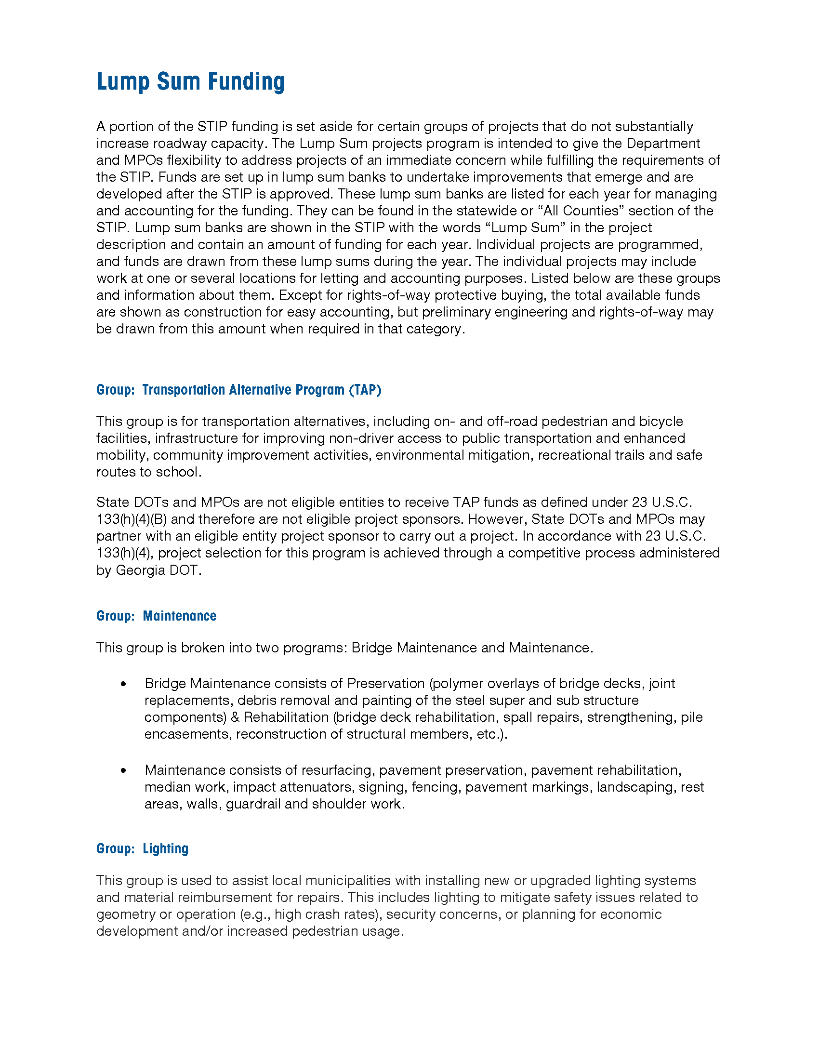

### 

### 

### MPO AUTHORIZED PROJECTS

### 

### PUBLIC PARTICIPATION PROCESS

#### Public Participation Requirements

A public review period will be required for the adoption of the Transportation Improvement Program. Public notice will be given by publishing an advertisement in a newspaper(s) of general circulation at least thirty (30) days before the final Transportation Improvement Program is adopted by the Policy Committee. Furthermore, the public review notice will also be made available to other interested parties In addition, the public review notice will also be made available in minority publications and on public transit buses for minority and low income groups. If determined by the Policy Committee that the final Transportation Improvement Program differs significantly from the one which was made available for public comment, and such plan raises new material issues which interested parties could not reasonably have foreseen from the public involvement efforts, an additional public comment period will be required. Public notice for this comment period will be given by publishing an advertisement in a newspaper(s) of general circulation, in addition to the other locations previously discussed and posting the notice on the website at least (15) days before the final Transportation Improvement Program is adopted by the Policy Committee. A summary, analysis, and report on the disposition of comments shall be made as part of the final document. The draft Transportation Improvement Program will be made available to the public at the Albany-Dougherty County Planning & Development Service and on the department’s website. Final copies will also be made available for information purposes and will be posted on the department’s website. If it is necessary to amend the TIP, a 30-day public review and comment period will be required. If no significant comments are received, no further action is required once the proposed amendment(s) have been approved by the Policy Committee. However, if comments are received which the MPO staff considers as potentially significant, the comments will be presented to the Policy Committee for consideration and appropriate action. Where a TIP amendment requires changes to the source MTP document, the TIP amendment and MTP public comment period will run concurrently.

#### Public Comment Period

The development of the TIP process involves a public outreach effort to identify community issues, concerns, and priorities. DARTS incorporated public participation techniques targeted towards developing the TIP document through a community meeting to inform the public of our intent to update the TIP, legal ads were published in the Albany Herald informing the public of the TIP update as well as being posted online on our Facebook page. A 30-day public comment period was conducted for review of the document. The draft TIP was available for public review on the MPO website, MPO office and local libraries. The public participation plan can be viewed in its entirety at <https://dartsmpo.org/wp-content/uploads/2022/01/2022-Public-Participation-Plan-.pdf>

### Amendment Process & Administrative Modifications

If the Policy Committee determines it is necessary to amend the final MTP and/or TIP, the proposed change will be brought before the Interagency Coordinating Committee (IAC) for review and comment.

IAC is a statewide body consisting of staff representatives throughout the state who are responsible for executing their respective regional transportation programs, plus staff from GDOT, FHWA and FTA. At the time the proposed change is brought before IAC, it will be classified as either an Administrative Modification or an Amendment. A comment period will be provided for proposed amendments to the MTP and TIP. To the extent practice cable, the review period will be 30 days. The CTC, TCC, and PC will review all proposed amendments. The public will be invited to comment when the topic is discussed at the meetings held by each Committee. The PC will accept or reject the proposed amendment.

### Administrative Modifications

### The following actions are eligible as Administrative Modifications to the MTP/TIP:

### Revise a project description without changing the project scope, conflicting with the environmental document, or changing the conformity finding in nonattainment and maintenance areas (less than 10% change in project termini according to GDOT). This change would not alter the original project intent.

### Splitting or combining projects.

### Federal funding category change.

### Minor changes in expenditures for transit projects as stipulated by GDOT.

### Roadway project phases may have a cost increase less than $2,000,000 or 20% of the amount to be authorized.

### Shifting projects within the TIP as long as the subsequent annual draft was submitted prior to September 30.

### Projects may be funded from lump sum banks as long as they are consistent with category definitions.

### An administrative modification can be processed in accordance with these procedures provided:

### It does not affect the air quality conformity determination, nor the network conformity years found in the travel demand model and the plan for nonattainment and maintenance areas.

### It does not impact financial constraint.

### It does not require public review and comment.

### Amendments to the Metropolitan Transportation Plan (MTP) and Transportation Improvement Plan (TIP)

The following actions are eligible as Amendments to the MTP and TIP.

• Addition or deletion of a project

• Addition or deletion of a phase of a project.

• Roadway project phases that increase in cost over the thresholds described in the Administrative Modification section.

• Addition of an annual TIP.

• Major change to scope of work of an existing project. A major change would be any change that alters the original intent i.e. a change in the number of through lanes, a change in termini of more than 10 percent.

• Shifting projects within the TIP which require redemonstrations of fiscal constraint.

***NOTICE OF PUBLIC REVIEW***



### 

### APPENDIX

***ACRONYMS USED IN THIS DOCUMENT***

* 3C - Continuing, Comprehensive, Cooperative
* APTA - American Public Transit Association
* APA - American Planning Association
* ATS - Albany Transit System
* BIL – Bipartisan Infrastructure Law
* CFR - Code of Federal Regulations
* CTC - Citizens Transportation Committee
* DARTS - Dougherty Area Regional Transportation Study
* EPA - Environmental Protection Agency
* FAST - Fixing America’s Surface Transportation
* FHWA - Federal Highway Administration
* FRA - Federal Railroad Administration
* FTA - Federal Transit Administration
* GDOT - Georgia Department of Transportation
* GIS - Graphic Information Systems
* HPMS - Highway Performance Monitoring System
* HSIP - Highway Safety Improvement Program
* IIJA – Infrastructure Investment and Jobs Act
* ITS - Intelligent Transportation Systems
* LEP - Limited English Proficiency
* MAP-21 - Moving Ahead for Progress in the 21st Century
* MPO - Metropolitan Planning Organization
* MTP – Metropolitan Transportation Plan
* NEPA - National Environmental Protection Act
* PC - Policy Committee
* PEL - Planning and Environmental Linkages
* PL - Planning Funds (Highway) Allocated for the MPO
* RTP - Regional Transportation Plan
* SRTS - Safe Routes to School
* STIP - State Transportation Improvement Program
* SWGRC - Southwest Georgia Regional Commission
* TCC - Technical Coordinating Committee
* TDP - Transit Development Plan
* TAZ - Traffic Analysis Zone
* TE - Transportation Enhancement
* TIP - Transportation Improvement Program
* UPWP - Unified Planning Work Program

### GLOSSARY

Project Name - This refers to the project such as road or bridge project.

DARTS No. - This is the number used by the DARTS staff to track a project from concept stage to completion.

GDOT No. - This refers to the Georgia Department of Transportation’s internal # for tracking a project from scope to completion. If a project does not have one of these numbers, it is either a totally locally funded project, or a project not yet made active by the DOT.

Project Description - This describes what will be done to the project referred to in the project title. This includes what specific action will be taken on the project (widening, bridge replacement, intersection improvements).

Regionally Significant - This describes a capacity-adding transportation project that is on a facility which serves regional transportation needs (such as access to and from the area outside of the region, major activity centers in the region, major planned developments such as new retail malls, sport complexes, etc. or transportation terminals as well as most terminals themselves) and would normally be included in the modeling of a metropolitan area’s transportation network, including at a minimum all minor arterial and above highways and all fixed guide way transit facilities that offer an alternative to regional highway travel.

Capacity Adding - This refers to whether a structure will increase a roadway’s capacity for additional traffic.

Bike/Ped - This details if there is a bicycle or pedestrian component that will be completed along with this project. There are recommended improvements included from the DARTS bicycle and pedestrian plan.

Connectivity - This describes how these upcoming projects coordinate with other projects in the Transportation Improvement Program (TIP) and the Metropolitan Transportation Plan (MTP). Length - This refers to the length of a project in miles and tenths of miles.

Number of Lanes – Existing, Future This section identifies the number of lanes on the roadway presently; lanes planned indicate number of lanes upon completion of project.

Existing and Future Volume (AADT) - This details the average annual daily traffic volume on the roadway segment for 2013 and 2040 respectively.

Status - this demonstrates the year in which this work will take place. Auth. (authorized) denotes funding already spent.

Phase - this section is broken down by fiscal year, showing the year in which work will begin. These phases include preliminary engineering (all work done in development of plans for a particular project), right-of-way, utilities, and construction.

### 

### ANNUAL-CERTIFICATION

**CERTIFICATION**

**OF THE**

**DARTS METROPOLITAN PLANNING ORGANIZATION**

Be it known to all, the below signees do hereby endorse and certify the Dougherty Area Regional Transportation Study (DARTS) MPO and further certify that the Metropolitan Planning Process is being conducted in accordance with all applicable requirements of:

### 23 U.S.C. 134, 49 U.S.C. 5305, and this subpart

* 1. Agreements are in place to address responsibilities of each MPO for its share of the overall Metropolitan Planning Area (MPA), where multiple Metropolitan Planning Organizations share geographic portions of a Transportation Management Area (TMA).
  2. All major modes of transportation are members of the MPO
  3. Any changes to the MPA boundaries were reflected in the Policy Board representation.
  4. Agreements or memorandums are signed and in place for identification of planning responsibilities among the MPO, GDOT, public transit operator(s), air quality agency(ies), or other agencies involved in the planning process.
  5. Roles and responsibilities are defined for the development of the Long Range Transportation Plan (LRTP) / Metropolitan Transportation Plan (MTP), Transportation Improvement Program (TIP), Unified Planning Work Program (UPWP) and other related planning documents.
  6. All MPO required planning products per 23 CFR Part 450, meeting minutes and agenda items are current and available on the MPO’s website.
  7. The metropolitan transportation planning process shall provide for the establishment and use of a performance-based approach to transportation decision-making to support the national goals described in 23

U.S.C. 150(b) and the general purposes described in 49 U.S.C. 5301(c).

#### UPWP (23 CFR Part 450.308)

* 1. The UPWP documents in detail the activities to be performed with Title 23 and the Federal Transit Act.
  2. The UPWP activities are developed, selected and prioritized with input from the State, MPO committees and public transit agency(ies).
  3. The final UPWP is submitted in a timely manner to GDOT with authorization occurring before the MPO’s fiscal year begins.
  4. Initial Adoption and Amendments to the UPWP are developed and processed in accordance with procedures outlined in the MPO’s Participation Plan.
  5. Planning activities and status reports are submitted quarterly by the MPO to GDOT and FHWA.

#### LRTP/MTP (23 CFR Part 450.324)

* 1. The LRTP/MTP incorporates a minimum 20-year planning horizon.
  2. The LRTP/MTP identifies both long-range and short-range strategies and actions leading to the development of an intermodal transportation system.
  3. The LRTP/MTP is fiscally constrained.
  4. The development of the LRTP/MTP and the TIP are coordinated with other providers of transportation (e.g. regional airports, maritime port operators).
  5. All of the Fixing America's Surface Transportation (FAST) Act planning factors were considered in the planning process.
  6. The LRTP/MTP includes a discussion of types of potential environmental mitigation activities and potential areas to carry out these activities in consultation with federal, state and tribal land management and regulatory agencies.
  7. The MPO approves the LRTP/MTP in a timely manner without entering into a planning lapse.
  8. Initial Adoption and Amendments to the LRTP/MTP are developed and processed in accordance with procedures outlined in the MPO’s Participation Plan.
  9. The transit authority’s planning process is coordinated with the MPO’s planning process.
  10. In non-attainment and maintenance areas the MPO, as well as FHWA and FTA, must make a conformity determination on any updated or amended LRTP/MTP in accordance with 40 CFR Part 93.

#### TIP 23 CFR Part 450.326)

* 1. The TIP is updated at least every 4 years, on a schedule compatible with STIP development.
  2. Each project included in the TIP is consistent with the LRTP/MTP.
  3. The MPO, GDOT and the transit operator collaborate on the development of the TIP.
  4. The TIP contains all projects to be funded under Title 23 U.S.C. and Title 49 U.S.C. Chapter 53.
  5. The TIP is financially constrained by year and revenue estimates reflect reasonable assumptions.
  6. The MPO TIP is included in the STIP by reference, without modification.
  7. Initial Adoption and Amendments to the TIP are developed and processed in accordance with procedures outlined in the MPO’s Participation Plan.
  8. In non-attainment and maintenance areas, the MPO as well as the FHWA and FTA must make a conformity determination on any updated or amended TIP in accordance with 40 CFR Part 93.

#### Participation Plan (23 CFR Part 450.316)

* 1. A 45-day comment period was provided before the Participation Plan was adopted/revised.
  2. Transportation plans, programs and projects provide timely information about transportation issues and processes to citizens and others who may be affected.
  3. Opportunities are provided for participation by local, State, and federal environmental resource and permit agencies where appropriate.
  4. The public involvement process demonstrates explicit consideration and responsiveness to public input received during the planning and program development process.
  5. The transportation planning process identifies and addresses the needs of those traditionally underserved, including low-income and minority households.
  6. The disposition of comments and changes in the final LRTP/MTP/TIP are documented and reported when significant comments are submitted.
  7. Additional time is provided if the “final” document is significantly different from the draft originally made available for public review.
  8. The MPO undertakes a periodic review of the public involvement process to determine if the process is efficient and provides full an open access for all.

#### List of Obligated Projects (23 CFR Part 450.334)

* 1. The MPO provides a listing for all projects for which funds are obligated each year, including bicycle and pedestrian facilities.
  2. The annual listing is made available to the public via the TIP or the LRTP/MTP.

### In non-attainment and maintenance areas, sections 174 and 176(c) and (d) of the Clean Air Act, as amended (42 U.S.C. 7504, 7506(c) and (d)) and 40 CFR part 93

* 1. The MPO’s UPWP incorporates all of the metropolitan transportation-related air quality planning activities addressing air quality goals, including those not funded by FHWA/FTA.
  2. Agreements exist to outline the process for cooperative planning within full nonattainment/maintenance areas that are not designated by the MPO planning area.
  3. The MPO coordinates the development of the LRTP/MTP with SIP development and the development of Transportation Control Measures (TCM) if applicable.
  4. The LRTP/MTP includes design concept and scope descriptions of all existing and proposed transportation facilities in sufficient detail, regardless of funding source, to permit conformity determinations.
  5. The MPO’s TIP includes all proposed federally and non-federally funded regionally significant transportation projects, including intermodal facilities.
  6. If applicable, the MPO ensures priority programming and expeditious implementation of

TCMs from the STIP.

### Title VI of the Civil Rights Act of 1964, as amended (42 U.S.C. 2000d-1) and 49 CFR part 21

* 1. The MPO has adopted goals, policies, approaches and measurements to address Title VI and related requirements.
  2. The public involvement process is consistent with Title VI of the Civil Rights Act of 1964 and the Title VI assurance execution by the State.
  3. The MPO has processes, procedures, guidelines, and/or policies that address Title VI, ADA, and DBE.
  4. The MPO has a documented policy on how Title VI complaints will be handled.
  5. The MPO has a demographic profile of the metropolitan planning area that includes identification of the locations of protected populations.
  6. As appropriate, the planning process identifies/considers/addresses the needs of protected/traditionally underserved populations (low-income/minority as defined by the U.S. Census Bureau).

### 49 U.S.C. 5332, prohibiting discrimination on the basis of race, color, creed, national origin, sex, or age in employment of business opportunity

* 1. The MPO adheres to all requirements prohibiting discrimination against a person under, a project, program, or activity receiving financial assistance under because of race, color, creed, national origin, sex, or age.

### Section 1101(b) of the FAST Act (Pub. L. 114-357) and 49 CFR part 26 regarding the involvement of disadvantaged business enterprises in U.S. DOT funded projects

* 1. The GDOT establishes overall goals for the percentage of work to be performed by DBE’s based on the projections of the number and types of federal-aid highway contracts to be awarded and the number and types of DBE’s likely to be available to compete for the contracts.

### 23 CFR part 230, regarding the implementation of an equal employment opportunity program on Federal and Federal- aid highway construction contracts

* 1. The MPO as required by Title VII of the Civil Rights Act of 1964, does not discriminate on employment opportunities based on race, color, religion, sex, or national origin;

### The provisions of the Americans with Disabilities Act of 1990 (42 U.S.C. 12101 et seq.) and 49 CFR parts 27, 37, and 38

* 1. The MPO as required by 49 U.S.C. 5332 prohibits discrimination on the basis of race, color, creed, national origin, sex, or age, and prohibits discrimination in employment or business opportunity, otherwise known as Title VI of the Civil Rights Act of 1964, as amended, 42 U.S.C. 2000d, and U.S. DOT regulations, “Nondiscrimination in Federally- Assisted Programs of the Department of Transportation—Effectuation of Title VI of the Civil Rights Act,” 49 CFR part 21 at 21.7.

### The Older Americans Act, as amended (42 U.S.C. 6101), prohibiting discrimination on the basis of age in programs or activities receiving Federal financial assistance

* 1. The MPO has identified strategies and services to meet the needs of older persons’ needs for transportation planning and programming.

### Section 324 of title 23 U.S.C. regarding the prohibition of discrimination based on gender

* 1. The MPO adheres to the Act on Equality between women and men and prohibits both direct and indirect discrimination based on gender.
  2. The MPO adheres to the Equal Pay Act of 1963 (EPA), which protects men and women who perform substantially equal work in the same establishment from sex-based wage discrimination;

### Section 504 of the Rehabilitation Act of 1973 (29 U.S.C. 794) and 49 CFR part 27 regarding discrimination against individuals with disabilities.

* 1. The MPO adheres to Title I and Title V of the Americans with Disabilities Act of 1990 (ADA), which prohibits employment discrimination against qualified individuals with disabilities in the private sector, and in state and local governments.

________________________________________________________________________________

Billy Breeden, Policy Committee Chairman Date

DARTS Metropolitan Planning Organization

________________________________________________________________________________

Vivian Canizares, Assistant State Transportation Planning Administrator Date

Georgia Department of Transportation, Office of Planning

________________________________________________________________________________

Matthew Markham, Deputy Director of Planning Date

### Georgia Department of Transportation, Office of Planning

### AMENDMENT PROCESS

**Statewide Transportation Improvement Program (STIP) and Transportation Improvement Program (TIP) Amendment Process**

The Federal Highway Administration (FHWA) and Federal Transit Administration (FTA) issued the Final Rule to revise the Statewide and Metropolitan Transportation Planning regulations incorporating changes from the Fixing America’s Surface Transportation Act (FAST). The revised regulations clearly define administrative modifications and amendments as actions to update plans and programs. 23 Code of Federal Regulations (CFR) Part 450.104 defines administrative modifications and amendments as follows:

1. Administrative modification “means a minor revision to a long-range statewide or metropolitan transportation plan, Transportation Improvement Program (TIP), or Statewide Transportation Improvement Program (STIP) that includes minor changes to project/project phase costs, minor changes to funding sources of previously-included projects, and minor changes to project/project phase initiation dates. Administrative Modification is a revision that does not require public review and comment, re-demonstration of fiscal constraint, or a conformity determination (in nonattainment and maintenance areas).”
2. Amendment “means a revision to a long-range statewide or metropolitan transportation plan, TIP, or STIP that involves a major change to a project included in a metropolitan transportation plan, TIP, or STIP, including the addition or deletion of a project or major change in project cost, project/project phase initiation dates, or a major change in design concept or design scope (e.g., changing project termini or the number of through traffic lanes). Changes to projects that are included only for illustrative purposes do not require an amendment. An amendment is a revision that requires public review and comment, re-demonstration of fiscal constraint, or a conformity determination (for metropolitan transportation plans and TIPs involving “non-exempt” projects in nonattainment and maintenance areas). In the context of a long-range statewide transportation plan, an amendment is a revision approved by the State in accordance with its public involvement process.”

The following procedures have been developed for processing administrative modifications and amendments to the STIP and Metropolitan Planning Organizations (MPOs) TIPs and Long-Range Transportation Plans (LRTPs). Processes described below detail procedures that are to be used to update an existing approved STIP or TIP and associated plan, if applicable. A key element of the amendment process is to assure that funding balances are maintained.

###### Administrative Modification

The following actions are eligible as Administrative Modifications to the STIP/TIP/LRTP:

1. Roadway project phases may have a cost increase up to $2,000,000 or 20% of the amount to be authorized.

* If the STIP amount is $10,000,000 or less, the cost may be increased up to $2,000,000.
* If the STIP amount is greater than $10,000,000, the cost may be increased by a maximum of 20%

1. Shifting projects within the 4-year STIP.

An administrative modification can be processed in accordance with these procedures provided that:

1. It does not affect the air quality conformity determination.
2. It does not impact financial constraint.
3. It does not require public review and comment.

The administrative modification process consists of a monthly list of notifications from GDOT to all involved parties, with change summaries sent on a monthly basis to the FHWA and FTA by the GDOT.

Projects may be funded from lump sum banks without any STIP/TIP modification or amendment as long as they are consistent with lump sum category definitions and do not go above the lump sum amounts programmed in the STIP. GDOT will submit quarterly reports detailing projects drawn from each lump sum bank with remaining balance to the FHWA.

###### Amendment

The following actions are eligible as Amendments to the STIP/TIP/LRTP:

1. Addition of a project.
2. Addition of a phase of a project.
3. Roadway project phases that increase in cost over the thresholds described in the Administrative Modification section.
4. Addition of an annual TIP.
5. Shifting projects within the 4-year STIP which require re-demonstration of fiscal constraint or when the subsequent annual draft STIP was not submitted prior to September 30.

Amendments to the STIP/TIP/LRTP will be developed in accordance with the provisions of 23 CFR Part 450. This requires public review and comment and responses to all comments, either individually or in summary form. For amendments in MPO areas, the public review process should be carried out in accordance with the procedures outlined in the Participation Plan. Georgia DOT will assure that the amendment process and the public involvement procedures have been followed. All amendments should be approved by FHWA and/or FTA.

Notes:

1. The date a TIP becomes effective is when the Governor or his designee approves it. For nonattainment and maintenance areas, the effective date of the TIP is based on the date of U.S. Department of Transportation’s positive finding of conformity.
2. The date the STIP becomes effective is when FHWA and FTA approve it.
3. The STIP is developed on the state fiscal year which is July 1-June 30.
4. Funds for cost increases will come from those set aside in the STIP financial plan by the GDOT for modifications and cost increases. Fiscal Constraint will be maintained in the STIP at all time.

### SYSTEM PERFORMANCE REPORT

Georgia Metropolitan Planning Organization Metropolitan Transportation Plan (MTP)/Transportation Improvement Program (TIP)

System Performance Report (Updated May 2023)

**Background**

Pursuant to the [Moving Ahead for Progress in the 21st Century Act (MAP-21) Act](https://www.transportation.gov/map21) enacted in 2012 and the [Fixing America's Surface Transportation Act (FAST Act)](https://www.fhwa.dot.gov/fastact/) enacted in 2015, state Departments of Transportation (DOT) and Metropolitan Planning Organizations (MPO) must apply a transportation performance management (TPM) approach in carrying out their federally-required transportation planning and programming activities. The process requires the establishment and use of a coordinated performance-based approach to transportation decision-making to support national goals for the federal-aid highway and public transportation programs.

To help transportation agencies take the necessary steps toward achieving the national goals, the Federal Highway Administration (FHWA) and the Federal Transit Administration (FTA) promulgated a series of rulemakings between 2016 and 2019 that established performance measures (PM) for the federal-aid highway and public transportation programs. Part of that series of rulemakings was the Statewide and Nonmetropolitan Transportation Planning; Metropolitan Transportation Planning Final Rule (The Planning Rule)[1] issued on May 27, 2016, that implemented the transportation planning and TPM provisions of MAP-21 and the FAST Act.

On November 15, 2021, President Joe Biden signed into law The Infrastructure Investment and Jobs Act (IIJA), also known as the [Bipartisan Infrastructure Law (BIL).](https://www.transportation.gov/bipartisan-infrastructure-law) The BIL (or IIJA) delivers generational investments in our roads and bridges, promotes safety for all road users, helps combat the climate crisis, and advances equitable access to transportation. The TPM approach from MAP-21 and the FAST Act is carried forward to this current law.

In accordance with National Performance Management Measures[2], the Planning Rule, as well as the Georgia Performance Management Agreement between the Georgia DOT (GDOT) and the Georgia Association of Metropolitan Planning Organizations (GAMPO), GDOT and each Georgia MPO must publish a System Performance Report (SPR) for applicable performance targets in their respective statewide and metropolitan transportation plans and programs.

* A System Performance Report (SPR) and subsequent updates is a federal requirement as part of any Metropolitan Transportation Plan (MTP) to evaluate the condition and performance of the transportation system with respect to the established performance targets;
* While the implemented Transportation Improvement Program (TIP) shows progress towards meeting the established performance targets.

The SPR presents the condition and performance of the transportation system with respect to required performance measures, documents performance targets and progress achieved in meeting the targets in comparison with previous reports. This is required for the following:

* In any statewide or metropolitan transportation plan or program amended or adopted after May 27, 2018, for Highway Safety/PM1 measures;
* In any statewide or metropolitan transportation plan or program amended or adopted after October 1, 2018, for transit asset measures;
* In any statewide or metropolitan transportation plan or program amended or adopted after May 20, 2019, for Pavement and Bridge Condition/PM2 and System Performance, Freight, and Congestion Mitigation and Air Quality/PM3 measures; and
* In any statewide or metropolitan transportation plan or program amended or adopted after July 20, 2021, for transit safety measures.

The DARTS 2045 Metropolitan Transportation Plan (MTP) was adopted on November 21, 2019. Per the Planning Rule and the Georgia Performance Management Agreement, the System Performance Report for the DARTS 2045 MTP is included, herein, for the required Highway Safety/PM1, Bridge and Pavement Condition/PM2, and System Performance and Freight.

**Highway Safety/PM1**

Effective April 14, 2016, the FHWA established the highway safety performance measures[3] to carry out the Highway Safety Improvement Program (HSIP). These performance measures are:

1. Number of fatalities;
2. Rate of fatalities per 100 million vehicle miles traveled;
3. Number of serious injuries;
4. Rate of serious injuries per 100 million vehicle miles traveled; and
5. Number of combined non-motorized fatalities and non-motorized serious injuries.

Safety performance targets are provided annually by the States to FHWA for each safety performance measure. GDOT submits the HSIP report annually to FHWA. The HSIP 2022 annual report was submitted to FHWA by August 31, 2022 and established the statewide safety targets for year 2023 based on an anticipated five-year rolling average (2019-2023). Georgia statewide safety performance targets for 2023 are included in Table 1, along with statewide safety performance for the two most recent reporting periods[4]. MPOs have 180 days after the states (GDOT) submit their targets to FHWA to either adopt the state targets or set their own PM1 targets; The 2023 MPO PM1 targets must be set by February 27, 2023.[5] The DARTS MPO adopted/approved the Georgia statewide safety performance targets on January 19, 2023

|  |
| --- |
| **Safety Performance Targets Timeline** (2022-2024) |

**2022**

**2023**

**2024**

**2025**

BY FEBRUARY 27, 2023

MPOs establish 2023 safety targets (no later than 180 days after GDOT establishes targets).

BY AUGUST 31, 2023

GDOT reports 2024 safety targets to FHWA in the HSIP Annual Report.

BY AUGUST 31, 2022

GDOT reports 2023 safety targets to FHWA in the HSIP Annual Report.

BY FEBRUARY 27, 2024

MPOs establish 2024 safety targets (no later than 180 days after GDOT establishes targets).

The latest safety conditions will be updated annually over a rolling 5-year window and reflected within each subsequent System Performance Report, to track performance over time in relation to baseline conditions and established targets.

Table 1 shows the Georgia statewide safety performance and targets and five-year rolling averages over the last three years.

Table 1. Statewide Highway Safety/PM1, System Conditions and Performance Targets (Due August each year to FHWA)

|  |  |  |  |
| --- | --- | --- | --- |
| Performance Measures | 2021 Georgia Statewide Performance Target  (Five-Year Rolling Average 2017-2021) | 2022 Georgia Statewide Performance Target  (Five-Year Rolling Average 2018-2022) | 2023 Georgia Statewide Performance Target  (Five-Year Rolling Average 2019-2023) |
| Number of Fatalities | 1,715 | 1,671 | 1,680 |
| Rate of Fatalities per 100 Million Vehicle Miles Traveled | 1.23 | 1.21 | 1.36 |
| Number of Serious Injuries | 6,407 | 8,443 | 8,966 |
| Rate of Serious Injuries per 100 Million Vehicle Miles Traveled | 4.422 | 4.610 | 7.679 |
| Number of Combined Non-Motorized Fatalities and Non-Motorized Serious Injuries | 686.5 | 793.0 | 802 |

Source: GDOT’s HSIP reports.

The DARTS MPO recognizes the importance of linking goals, objectives, and investment priorities to stated performance objectives, and that establishing this link is critical to the achievement of national transportation goals and statewide and regional performance targets. As such, the 2045 MTP directly reflects the goals, objectives, performance measures, and targets as they are available and described in other State and public transportation plans and processes; specifically, the Georgia Strategic Highway Safety Plan (SHSP), the Georgia Highway Safety Improvement Program (HSIP), and the Georgia 2050 Statewide Transportation Improvement Plan (SWTP)/2021 Statewide Strategic Transportation Plan (SSTP).

* The Georgia SHSP is intended to reduce the number of fatalities and serious injuries resulting from motor vehicle crashes on public roads in Georgia. Existing highway safety plans are aligned and coordinated with the SHSP, including (but not limited to) the Georgia HSIP, MPO and local agencies’ safety plans. The SHSP guides GDOT, the Georgia MPOs, and other safety partners in addressing safety and defines a framework for implementation activities to be carried out across Georgia.
* The GDOT HSIP annual report provide for a continuous and systematic process that identifies and reviews traffic safety issues around the state to identify locations with potential for improvement. The ultimate goal of the HSIP process is to reduce the number of crashes, injuries and fatalities by eliminating certain predominant types of crashes through the implementation of engineering solutions.
* The 2021 SSTP/2050 SWTP combines GDOT’s strategic business case for transportation investment with the long-range, comprehensive transportation planning considerations under Federal law. The SSTP/SWTP is organized into three investment categories, reflecting three major ways people and freight move in Georgia; statewide freight and logistics, people mobility in Metro Atlanta, and people mobility in emerging metros and rural Georgia. The plan identifies strategies to bring about Foundational, Catalytic, and Innovation investments for the above mentioned categories.[6]
* The DARTS 2045 MTP increases the safety of the transportation system for motorized and non-motorized users as required by the Planning Rule. The MTP identifies safety needs within the metropolitan planning area and provides funding for targeted safety improvements. To support progress towards approved highway safety targets, the FY 2024-2027 TIP includes a number of key safety investments. A total of $3,956,000 has been programmed in the FY 2024-2027 TIP to improve highway safety; averaging approximately $989,000 per year. The DARTS MPO will do further analysis of PM1 Safety Targets in the development of its 2050 MTP.
* The DARTS 2022 Bicycle & Pedestrian plan examines MPO’s policies, projects, high-traffic areas, and community input to establish strategies and performance measures. These measures guide the planning, funding, and implementation of projects to create a recommended network for walking and biking throughout the DARTS MPO area. The plan considers bike and pedestrian improvements based on existing conditions, existing plans, and the needs of pedestrians and bicyclists. Consistent with the 2045 Long Range Plan and Southwest Georgia Regional Commission’s Bicycle and Pedestrian Plan, the plan identifies both specific projects for implementation and general policies to guide future decision making.

Table 2: DARTS MPO TIP Projects, 2024-2027

|  |  |  |  |  |  |  |  |  |
| --- | --- | --- | --- | --- | --- | --- | --- | --- |
|  | | | PM1 | PM2 | | PM3 | | |
| PI# | Cost | Work Type | Safety | Bridges | Pavement | System Reliability | Truck Reliability | CMAQ* |
| T007344 | $1,887,079 | Operational Improvement | P410C20T6#y1 |  |  |  |  |  |
| T007050 | $2,660,252 | Operational Improvement | P410C20T6#y1 |  |  |  |  |  |
| T008380 | $3,965,872 | Operational Improvement |  |  |  |  |  |  |
| T008381 | $3,965,872 | Operational Improvement |  |  |  |  |  |  |



**Pavement and Bridge Condition/PM2**

Effective May 20, 2017, FHWA established performance measures to assess pavement condition[7] and bridge condition[8] for the National Highway Performance Program. This second FHWA performance measure rule (PM2) established six performance measures:

1. Percent of Interstate pavements in good condition;
2. Percent of Interstate pavements in poor condition;
3. Percent of non-Interstate National Highway System (NHS) pavements in good condition;
4. Percent of non-Interstate NHS pavements in poor condition;
5. Percent of NHS bridges by deck area classified as in good condition; and
6. Percent of NHS bridges by deck area classified as in poor condition.

Pavement Condition Measures

The pavement condition measures represent the percentage of lane-miles on the Interstate or non-Interstate NHS that are in good condition or poor condition. FHWA established five metrics to assess pavement condition: International Roughness Index (IRI); cracking percent; rutting; faulting; and Present Serviceability Rating (PSR). For each metric, a threshold is used to establish good, fair, or poor condition.

Pavement condition is assessed using these metrics and thresholds. A pavement section in good condition if three metric ratings are good, and in poor condition if two or more metric ratings are poor. Pavement sections that are not good or poor are considered fair.

The pavement condition measures are expressed as a percentage of all applicable roads in good or poor condition. Pavement in good condition suggests that no major investment is needed. Pavement in poor condition suggests major reconstruction investment is needed due to either ride quality or a structural deficiency.

Bridge Condition Measures

The bridge condition measures represent the percentage of bridges, by deck area, on the NHS that are in good condition or poor condition. The condition of each bridge is evaluated by assessing four bridge components: deck, superstructure, substructure, and culverts. FHWA created a metric rating threshold for each component to establish good, fair, or poor condition. Every bridge on the NHS is evaluated using these component ratings. If the lowest rating of the four metrics is greater than or equal to seven, the structure is classified as good. If the lowest rating is less than or equal to four, the structure is classified as poor. If the lowest rating is five or six, it is classified as fair.

To determine the percent of bridges in good or in poor condition, the sum of total deck area of good or poor NHS bridges is divided by the total deck area of bridges carrying the NHS. Deck area is computed using structure length and either deck width or approach roadway width. Good condition suggests that no major investment is needed. Bridges in poor condition are safe to drive on; however, they are nearing a point where substantial reconstruction or replacement is needed.

Pavement and Bridge Targets

Pavement and bridge condition performance is assessed and reported over a four-year performance period. The first performance period began on January 1, 2018, and runs through

December 31, 2021. GDOT reported baseline PM2 performance and targets to FHWA on October 1, 2018, and will report updated performance information at the midpoint and end of the performance period. The second four-year performance period covers January 1, 2022, to December 31, 2025, with additional performance periods following every four years. The PM2 rule requires states and MPOs to establish two-year and/or four-year performance targets for each PM2 measure. Current two-year targets under the second four-year performance period represent expected pavement and bridge condition at the end of calendar year 2023, while the current four-year targets represent expected condition at the end of calendar year 2025.

|  |
| --- |
| **SECOND** Performance Period (January 1, 2022, to December 31, 2025) |

**2022**

**2023**

**2024**

**2027**

BY *DECEMBER 16, 2022\**

GDOT establishes statewide targets for 2023 and 2025 and reports performance and targets to FHWA (Baseline).

BY JUNE 14, 2023

MPOs establish 2025 targets (no later than 180 days after GDOT establishes targets).

BY OCTOBER 1, 2024

GDOT reports statewide performance and progress toward targets

(Mid-Performance).

**2025**

BY OCTOBER 1, 2026

GDOT reports statewide performance and progress targets (Full-Performance).

**2026**

*\* FHWA changed the due date from October 1, 2022, due to a technical issue with the reporting system.*

States establish targets as follows:

* Percent of Interstate pavements in good and poor condition – four-year targets;
* Percent of non-Interstate NHS pavements in good and poor condition – two-year and four-year targets; and
* Percent of NHS bridges by deck area in good and poor condition – two-year and four-year targets.

MPOs have 180 days after the states (GDOT) submit their targets to FHWA to establish four-year targets for each measure by either agreeing to the statewide targets or setting quantifiable targets for the MPO’s planning area that differ from the state targets.

GDOT established current statewide two-year and four-year PM2 targets on December 16, 2022. MPOs have 180 days from December 16, 2022 to adopt the state PM2 targets or set their own PM2 targets; The MPO second performance period PM2 targets must be set by June 14, 2023. The DARTS MPO adopted/approved the Georgia statewide PM2 targets on April 20, 2023 Table 2 presents statewide baseline performance for each PM2 measure as well as the current two-year and four-year statewide targets established by GDOT.

On or before October 1, 2024, GDOT will provide FHWA with a detailed mid-performance report of pavement and bridge condition performance covering the period of January 1, 2022, to December 31, 2023, for the second performance period. GDOT and the DARTS MPO will have the opportunity at that time to revisit the four-year PM2 targets.

Table 3. Pavement and Bridge Condition/PM2 Performance and Targets

|  |  |  |  |
| --- | --- | --- | --- |
| Performance Measures | Georgia Performance (Baseline 2021) | Georgia 2-year Target (2023) | Georgia 4-year Target (2025) |
| Percent of Interstate pavements in good condition | 67.4% | 50.0% | 50.0% |
| Percent of Interstate pavements in poor condition | 0.1% | 5.0% | 5.0% |
| Percent of non-Interstate NHS pavements in good condition | 49.2% | 40.0% | 40.0% |
| Percent of non-Interstate NHS pavements in poor condition | 0.6% | 12.0% | 12.0% |
| Percent of NHS bridges (by deck area) in good condition | 79.1% | 50.0% | 60.0% |
| Percent of NHS bridges (by deck area) in poor condition | 0.5% | 10.0% | 10.0% |

The DARTS MPO recognizes the importance of linking goals, objectives, and investment priorities to stated performance objectives, and that establishing this link is critical to the achievement of national transportation goals and statewide and regional performance targets. As such, the 2045 MTP directly reflects the goals, objectives, performance measures, and targets as they are available and described in other State and public transportation plans and processes; specifically, Georgia’s Transportation Asset Management Plan (TAMP), the Georgia Interstate Preservation Plan, and the current SSTP/2050 SWTP.

* MAP-21 initially required GDOT to develop a TAMP for all NHS pavements and bridges within the state In addition, BIL requires considering extreme weather and resilience as part of the life-cycle planning and risk management analyses within a State TAMP process and evaluation. GDOT’s TAMP describes Georgia’s current bridge (bridge culverts) and pavement asset management processes for improving and preserving the condition of the National Highway System (NHS), which comprised of approximately 7,200 miles of roadway within the State which includes interstates, state routes and local roads as well as 4,300 structures of both bridges and bridge culverts. GDOT has recently developed TAMP for FY 2022-2031, which uses life-cycle planning and outlines the priorities and investment strategies leading to a program of projects that would make progress toward achievement of GDOT’s statewide pavement and bridge condition targets and cost effectively manage and preserve these assets over the next 10 years.
* The Georgia Interstate Preservation Plan applied a risk profile to identify and communicate Interstate preservation priorities; this process leveraged a combination of asset management techniques with risk management concepts to prioritize specific investment strategies for the Interstate system in Georgia.
* The 2021 SSTP/2050 SWTP combines GDOT’s strategic business case for transportation investment with the long-range, comprehensive transportation planning considerations under Federal law. The SSTP/SWTP is organized into three investment categories, reflecting three major ways people and freight move in Georgia; statewide freight and logistics, people mobility in Metro Atlanta, and people mobility in emerging metros and rural Georgia. The plan identifies strategies to bring about Foundational, Catalytic, and Innovation investments for the above mentioned categories.[9]
* The DARTS MPO’s 2045 MTP addresses infrastructure preservation and identifies pavement and bridge infrastructure needs within the metropolitan planning area, and allocates funding for targeted infrastructure improvements. To support progress towards GDOT’s statewide PM2 targets, the FY 2024-2027 TIP includes a number of investments that will maintain pavement and bridge condition performance. Investments in pavement and bridge condition include pavement replacement and reconstruction, bridge replacement and reconstruction, new bridge and pavement capacity, and system resiliency projects that improve NHS bridge components (e.g., upgrading culverts). The FY 2024-27 has 2 bridge projects programmed for the fiscal period that include bridge replacement and Preliminary Engineering. The table below breaks down funding allocated for these projects.

Table 4: DARTS MPO TIP Projects, 2024-2027

|  |  |  |  |  |  |  |  |  |
| --- | --- | --- | --- | --- | --- | --- | --- | --- |
|  | | | PM1 | PM2 | | PM3 | | |
| PI# | Cost | Work Type | Safety | Bridges | Pavement | System Reliability | Truck Reliability | CMAQ* |
| 0013583 | $100,000 | Bridges |  | P410C20T6#y1 |  |  |  |  |
| 0013992 | $17,650,340 | Bridges |  | P410C20T6#y1 |  |  |  |  |

|  |  |  |  |  |  |  |  |  |  |  |
| --- | --- | --- | --- | --- | --- | --- | --- | --- | --- | --- |
| 0013583 | BR-4 | SR 234 SBL @ GA-FL RAILNET INC ALBANY - SE SECTION | Bridges | 2027 | PE | Y236 | $80,000 | $20,000 | $0 | $100,000 |
| 0013992 |  | SR 520BU @ FLINT RIVER IN ALBANY | Bridges | 2027 | CST | Y236 | $14,114,981 | $3,528,745 | $0 | $17,643,727 |
| 0013992 |  | SR 520BU @ FLINT RIVER IN ALBANY | Bridges | 2027 | UTL | Y236 | $5,291 | $1,323 | $0 | $6,613 |

**System Performance, Freight, and Congestion Mitigation & Air Quality Improvement Program/PM3**

Effective May 20, 2017, FHWA established measures to assess performance of the National Highway System[10], freight movement on the Interstate system[11], and the Congestion Mitigation and Air Quality Improvement (CMAQ) Program[12]. This third FHWA performance measure rule (PM3) established six performance measures, described below.

*National Highway System Performance:*

1. Percent of person-miles on the Interstate system that are reliable;
2. Percent of person-miles on the non-Interstate NHS that are reliable;

*Freight Movement on the Interstate:*

1. Truck Travel Time Reliability Index (TTTR);

*Congestion Mitigation and Air Quality Improvement (CMAQ) Program:*

1. Annual hours of peak hour excessive delay per capita (PHED);
2. Percent of non-single occupant vehicle travel (Non-SOV); and
3. Cumulative two-year and four-year reduction of on-road mobile source emissions for CMAQ funded projects (CMAQ Emission Reduction).

The CMAQ performance measures apply to states and MPOs with projects financed with CMAQ funds whose boundary contains any part of a nonattainment or maintenance area for ozone, carbon monoxide or particulate matter. The DARTS MPO meets air quality standards, therefore, the CMAQ measures do not apply and are not reflected in the System Performance Report.

### System Performance Measures

The two System Performance measures assess the reliability of travel times on the Interstate or non-Interstate NHS system. The performance metric used to calculate reliability is the Level of Travel Time Reliability (LOTTR). LOTTR is defined as the ratio of longer travel times (80th percentile) to a normal travel time (50th percentile) over all applicable roads during four time periods (AM peak, Mid-day, PM peak, and weekends) that cover the hours of 6 AM to 8 PM each day.

The LOTTR ratio is calculated for each segment of applicable roadway, essentially comparing the segment with itself. A segment is deemed to be reliable if its LOTTR is less than 1.5 during all four time periods. If one or more time periods has a LOTTR of 1.5 or above, that segment is unreliable.

The measures are expressed as the percent of person-miles traveled on the Interstate or non-Interstate NHS system that are reliable. Person-miles take into account the number of people traveling in buses, cars, and trucks over these roadway segments. To determine total person miles traveled, the vehicle miles traveled (VMT) on each segment is multiplied by average vehicle occupancy. To calculate the percent of person miles traveled that are reliable, the sum of the number of reliable person miles traveled is divided by the sum of total person miles traveled.

### Freight Movement Performance Measure

The Freight Movement performance measure assesses reliability for trucks traveling on the Interstate. A TTTR ratio is generated by dividing the 95th percentile truck travel time by a normal travel time (50th percentile) for each segment of the Interstate system over five time periods throughout weekdays and weekends (AM peak, Mid-day, PM peak, weekend, and overnight) that cover all hours of the day. For each segment, the highest TTTR value among the five time periods is multiplied by the length of the segment. The sum of all length-weighted segments is then divided by the total length of Interstate to generate the TTTR Index.

### PM3 Performance Targets

Performance for the PM3 measures is assessed and reported over a four-year performance period. For all PM3 measures, the first performance period began on January 1, 2018, and will end on December 31, 2021. GDOT reported baseline PM3 performance and targets (for First Performance Period) to FHWA on October 1, 2018, the baseline PM3 performance and targets (for Second Performance Period) to FHWA on December 16, 2022, and will report updated performance information at the midpoint and end of the performance period. The second four-year performance period will cover January 1, 2022, to December 31, 2025, with additional performance periods following every four years.

The PM3 rule requires state DOTs and MPOs to establish two-year and/or four-year performance targets for each PM3 measure. For all targets, the current two-year and four-year targets represent under the second four-year performance period expected performance at the end of calendar years 2023 and 2025.

|  |
| --- |
| **SECOND** Performance Period (January 1, 2022, to December 31, 2025) |

**2022**

**2023**

**2024**

**2027**

BY *DECEMBER 16, 2022\**

GDOT establishes statewide targets for 2023 and 2025 and reports performance and targets to FHWA (Baseline).

BY JUNE 14, 2023

MPOs establish 2025 targets (no later than 180 days after GDOT establishes targets).

BY OCTOBER 1, 2024

GDOT reports statewide performance and progress toward targets

(Mid-Performance).

**2025**

BY OCTOBER 1, 2026

GDOT reports statewide performance and progress targets (Full-Performance).

**2026**

*\* FHWA changed the due date from October 1, 2022, due to a technical issue with the reporting system.*

States establish targets as follows:

* Percent of person-miles on the Interstate system that are reliable – two-year and four-year targets;
* Percent of person-miles on the non-Interstate NHS that are reliable – four-year targets;
* Truck Travel Time Reliability – two-year and four-year targets;
* Annual hours of peak hour excessive delay per capita (PHED) – four-year targets;
* Percent of non-single occupant vehicle travel (Non-SOV) – two-year and four-year targets; and
* CMAQ Emission Reductions – two-year and four-year targets.

MPOs establish four-year targets for the System Performance, Freight Movement, and PHED measures, and two-year and four-year targets for the Non-SOV and CMAQ Emission Reduction measures. MPOs establish targets by either agreeing to program projects that will support the statewide targets, or setting quantifiable targets for the MPO’s planning area that differ from the state targets.

GDOT established statewide PM3 targets and submitted to FHWA by December 16, 2022. The DARTS adopted/approved the Georgia statewide PM3 targets on April 24, 2023. Table 5 presents statewide baseline performance for each PM3 measure as well as the current two-year and four-year statewide targets established by GDOT.

On or before October 1, 2024, GDOT will provide FHWA with a detailed mid-performance report of PM3 performance covering the period of January 1, 2022, to December 31, 2023, for the second performance period. GDOT and the DARTS MPO will have the opportunity at that time to revisit the four-year PM3 targets.

Table 5 System Performance/Freight Movement/CMAQ (PM3) Performance and Targets

|  |  |  |  |
| --- | --- | --- | --- |
| Performance Measure | Georgia Performance (Baseline 2021) | Georgia 2-year Target (2023) | Georgia 4-year Target (2025) |
| Percent of person-miles on the Interstate system that are reliable | 82.8% | 73.9% | 68.4% |
| Percent of person-miles on the non-Interstate NHS that are reliable | 91.9% | 87.3% | 85.3% |
| Truck Travel Time Reliability Index | 1.47 | 1.62 | 1.65 |

*\*4-year Cumulative Emission Reductions from 2018-2021*

The DARTS MPO recognizes the importance of linking goals, objectives, and investment priorities to stated performance objectives, and that establishing this link is critical to the achievement of national transportation goals and statewide and regional performance targets. As such, the 2045 MTP directly reflects the goals, objectives, performance measures, and targets as they are available and described in other State and public transportation plans and processes; specifically, the Georgia Statewide Freight and Logistics Action Plan, and the current 2021 SSTP/2050 SWTP.

* The 2023 Georgia Freight Plan documents freight planning activities and investments in the state, identifies and assesses current and future freight needs and challenges incorporating both technical analysis and stakeholder engagement, and guides freight-related transportation decisions and investments. The plan integrates policy positions and strategies from existing documents to help identify and prioritize freight investments critical to the state’s economic growth and global competitiveness. The Georgia Freight Plan establishes specific goals for freight transportation and addresses freight issues that are not covered in other statewide planning documents.[13]
* The 2021 SSTP/2050 SWTP combines GDOT’s strategic business case for transportation investment with the long-range, comprehensive transportation planning considerations under Federal law. The SSTP/SWTP is organized into three investment categories, reflecting three major ways people and freight move in Georgia; statewide freight and logistics, people mobility in Metro Atlanta, and people mobility in emerging metros and rural Georgia. The plan identifies strategies to bring about Foundational, Catalytic, and Innovation investments for the above mentioned categories.[14]
* The DARTS 2045 MTP addresses reliability, freight movement, congestion, and emissions and identifies needs for each of these issues within the metropolitan planning area and allocates funding for targeted improvements. A total of $3,650,111.00 has been programmed in the FY 2024-2027 TIP to address truck travel time reliability; congestion and emissions averaging approximately $641,000 per year. The DARTS MPO will analyze PM3 Targets in the development of its 2050 MTP.
* The DARTS 2022 Freight Profile ensures consistency with federal freight planning guidelines and better position DARTS to improve goods movement in the Albany region. The locally-driven planning process focused on gaining consensus on freight priorities to promote regional economic competitiveness. The plan addresses roadway, rail, and air cargo movement for current and future freight needs.

Table 6 System Performance/Freight Movement/CMAQ (PM3) Performance and Targets

|  |  |  |  |  |  |  |  |  |
| --- | --- | --- | --- | --- | --- | --- | --- | --- |
|  | | | PM1 | PM2 | | PM3 | | |
| PI# | Cost | Work Type | Safety | Bridges | Pavement | System Reliability | Truck Reliability | CMAQ* |
| T007344 | $1,887,079 | Operational Improvement |  |  |  |  |  |  |
| T007050 | $2,660,252 | Operational Improvement | P410C20T6#y1P410C20T6#y1 |  |  | P410C20T6#y1 |  |  |
| T008380 | $3,965,872 | Operational Improvement |  |  |  |  |  |  |
| T008381 | $3,965,872 | Operational Improvement | P410C20T6#y1 |  |  | P410C20T6#y1P410C20T6#y1 |  |  |



# Appendix A: Project Types

The matrix below is based on 2024-2027 STIP projects as general guidelines; In reality, individual projects may yield benefits to other PMs than shown here given specific project characteristics.

Table 5: Projects/Work Types That Support Each Performance Measure Targets

|  |  |  |  |  |  |  |  |  |
| --- | --- | --- | --- | --- | --- | --- | --- | --- |
| Work Type | PM1 | PM2 | | PM3 | | | | |
| Safety | Bridges | Pavement | System Reliability | Truck Reliability | CMAQ* | | |
| PHED | Non-SOV | Emissions Reduction |
| Bicycle / Pedestrian Facilities | P410C20T6#y1 |  |  |  |  |  | P410C20T6#y1P410C20T6#y1 |  |
| Bridges |  | P410C20T6#y1 |  |  |  |  |  |  |
| Drainage Improvements |  |  | P410C20T6#y1 |  |  |  |  |  |
| Grade Separation |  |  |  | P410C20T6#y1 |  | P410C20T6#y1 |  |  |
| Interchange |  |  |  | P410C20T6#y1 | P410C20T6#y1 | P410C20T6#y1P410C20T6#y1P410C20T6#y1 |  |  |
| Intersection Improvement | P410C20T6#y1 |  |  | P410C20T6#y1 |  |  |  |  |
| ITS | P410C20T6#y1 |  |  | P410C20T6#y1 |  |  |  | P410C20T6#y1 |
| Lighting | P410C20T6#y1 |  |  |  |  |  |  |  |
| Managed Lanes | P410C20T6#y1 |  |  | P410C20T6#y1 | P410C20T6#y1 | P410C20T6#y1 |  | P410C20T6#y1 |
| Operational Improvement | P410C20T6#y1 |  | P410C20T6#y1 | P410C20T6#y1 | P410C20T6#y1 | P410C20T6#y1 |  |  |
| Pavement Rehabilitation | P410C20T6#y1 |  |  |  |  |  |  |  |
| Railroad Crossing | P410C20T6#y1 |  |  | P410C20T6#y1 |  |  |  |  |
| Transit |  |  |  |  |  |  | P410C20T6#y1 | P410C20T6#y1 |
| Truck Lanes |  |  |  |  | P410C20T6#y1 |  |  |  |
| Widening |  |  |  | P410C20T6#y1 |  | P410C20T6#y1 |  |  |

* *The CMAQ measures including PHED, Non-SOV, and Emission Reduction apply only within the boundaries of each U.S. Census Bureau-designated urbanized area (UZA) that contains a NHS road, has a population of more than 200 thousand, and contains any part of a nonattainment or maintenance area for ozone, carbon monoxide or particulate matter. In Georgia, the CMAQ measures only apply to statewide for GDOT as well as individually for ARC and CBMPO*

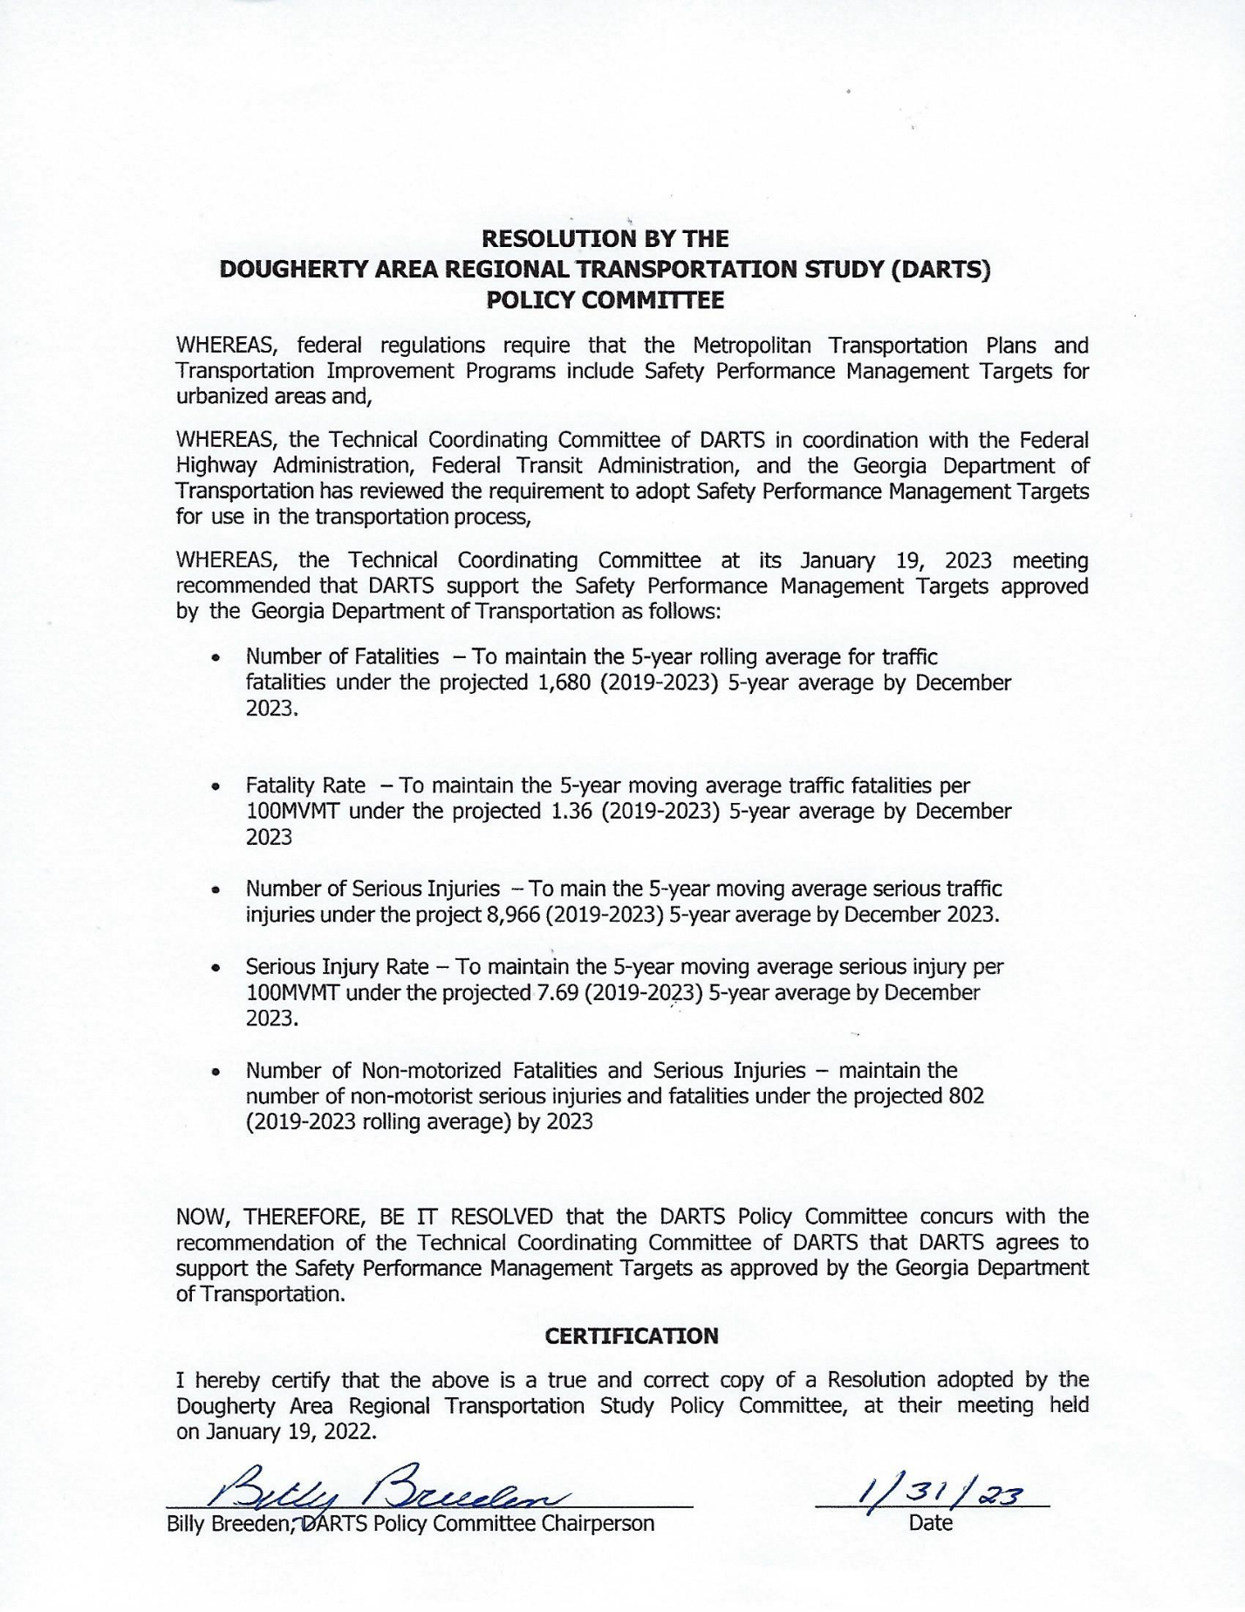

**RESOLUTION BY THE**

**DOUGHERTY AREA REGIONAL TRANSPORTATION STUDY (DARTS) POLICY COMMITTEE SETTING**

**PERFORMANCE MANAGEMENT TARGETS (PM2 & PM3)**

**WHEREAS**, federal regulations require that the Metropolitan Transportation Plans and Transportation Improvement Programs include Safety Performance Management Targets for urbanized areas and,

**WHEREAS**, the Technical Coordinating Committee of DARTS in coordination with the Federal Highway Administration, Federal Transit Administration, and the Georgia Department of Transportation has reviewed the requirement to adopt PM2 (Bridge and Pavement), and PM 3 (National Highway System, Freight, and CMAQ) Performance Management Targets for use in the transportation process,

**WHEREAS**, the Technical Coordinating Committee at its April 20, 2023 meeting recommended that DARTS support the Safety Performance Management Targets approved by the Georgia Department of Transportation as follows:

**PM 2 TARGETS**

**Table 1 Bridge Level of Service Measures**

|  |  |  |  |  |
| --- | --- | --- | --- | --- |
| **ASSET** | **PERFORMANCE MEASURE** | **DESCRIPTION** | **2-YEAR TARGET** | **4-YEAR TARGET** |
| **Bridge Structures** | Percent of NHF Bridge in **Poor condition** as a percentage of total NHS bridge deck area | Bridge Conditions are based on results of inspection on all Bridge structures. Bridges rated as “Poor” are safe to drive on; however, they are nearing a point where it is necessary to either replace the bridge or extend its service life through substantial rehabilitations investments | ≤ 10% (NHS) in Poor Condition | ≤ 10% (NHS) in Poor Condition |
| **Bridge Structures** | Percent of NHS Bridges in **Good condition** as a percentage of total NHS bridge deck area | Bridges rated as “Good” will be evaluated as to cost of to maintain Good condition. Bridges rated as “Fair” will be evaluated as to cost of replacement vs. rehabilitation to bring the structure back to the condition rating of Good. | **≥** 50% (NHS) in Good Condition | **≥** 60% (NHS) in Good Condition |

**Note:** *GDOT will have an opportunity to revisit and adjust (if necessary) the 4-year target in 2024*

**Table 2 Pavement Level of Services**

|  |  |  |  |
| --- | --- | --- | --- |
| **ASSET** | **PERFORMANCE MEASURE** | **DESCRIPTION** | **TARGET** |
| **Interstate NHS** | Percent of Interstate NHS pavements in **Poor condition** | Pavement conditions are measured through field inspections. Pavements in “poor” condition are in need of work due to either the ride quality or due to a structural deficiency. | ≤ 5% (NHS) in Poor Condition |
| **Interstate NHS** | Percent of Interstate NHS pavements in **Good condition** | Interstate pavement rated as “good” will be considered for potential pavement preservation treatments to maintain the “good” rating. | **≥** 50% (NHS) in Good Condition |
| **Non-Interstate NHS** | Percent of NHS pavements in **Poor condition** | Non-interstate NHS pavements in “poor” condition are in need of major maintenance. These will be evaluated for potential projects. | ≤ 12% (NHS) in Poor Condition |
| **Non-Interstate NHS** | Percent of NHS pavements in **Good condition** | Non-interstate NHS pavements in “good” condition will be evaluated for potential preservation treatments. | **≥** 40% (NHS) in Good Condition |

**Note:** *The 2-yr and 4-yr targets are the same.  GDOT will have an opportunity to revisit and adjust (if necessary) the 4-year target in 2024*

**PM3 TARGETS**

**Summary of the PM 3 Performance Measures**

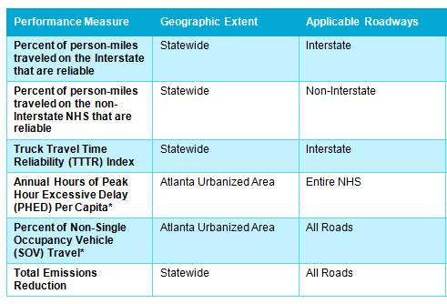

**PM 3 Targets**

|  |  |  |
| --- | --- | --- |
| **Performance Measure** | **2-year Target** | **4-year Target** |
| **Percent of person-miles traveled on the Interstate that are reliable** | 73.9% | 68.4% |
| **Percent of person-miles traveled on the non-Interstate NHS that are reliable** | 87.3% | 85.3% |
| **Truck Travel Time Reliability (TTTR) Index** | 1.62 | 1.65 |
| **Annual Hours of Peak Hour Excessive Delay (PHED) Per Capita\*** | 23.7 hours | 27.2 hours |
| **Percent of Non-Single Occupancy Vehicle (SOV) Travel\*** | 22.7% | 22.7% |
| **Total Emissions Reduction** | VOC: 157.200 kg/day;  NOx: 510.900 kg/day | VOC: 257.100 kg/day;  NOx: 904.200 kg/day |

**Note:** *GDOT will have an opportunity to revisit and adjust (if necessary) the 4-year target in 2024*

NOW, THEREFORE, BE IT RESOLVED that the DARTS Policy Committee concurs with the recommendation of the Technical Coordinating Committee of DARTS that DARTS agrees to support the Safety Performance Management Targets as approved by the Georgia Department of Transportation.

**CERTIFICATION**

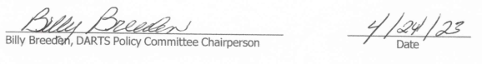I hereby certify that the above is a true and correct copy of a Resolution adopted by the Dougherty Area Regional Transportation Study Policy Committee, at their meeting held on April 20, 2023.

### Public Comment

|  |  |  |  |  |  |  |  |
| --- | --- | --- | --- | --- | --- | --- | --- |
| **Document Title:** | | DARTS FY24-27 TIP | | | **Project Number:** | Albany | |
| **Document Date:** | | May Draft | | | **Comment Date:** | 6-1-23 | |
| **Comment #** | **Page #** | **Section** | **¶** | **Comment** | **Response** | | **New Page** |
| 1 |  | Introduction |  | There are two resolutions in the introduction. Please remove one.  Change “… is drawn from the DARTS 2045 Transportation Plan;” to “… is consistent with.” Bold the third “WHEREAS.”  DARTS is not the 3C process. Please revise.  There are duplicative statements within the introduction. Please revise and QA/QC.  There are currently 10 Planning Factors, not 11.  The MTP goals sentence “The Goals of DARTS MPO...” appears to be incomplete. | One of the two resolutions was removed, and changes made to wording.  The 3C Process has been removed from these sections.  The introduction has been revised to remove duplicative statements.  Changes made to Planning Factors and listed as 10.  Sentence reworked to make it complete. | | #5 |
| 2 | 16-19 | Introduction |  | It is good that the PEAs are acknowledged, however, it is not required to include the PEAs in the TIP. If they are included, there should be a connection between the PEAs and the contents of the TIP. Please remove or revise accordingly. | Planning Emphasis Area’s (PEAs) have been removed from the document. | |  |
| 3 | 27 | Financial Plan |  | The revenue estimates table begins from 2025 to 2030. Is it possible to add 2024 so that all TIP years are covered? | 2024 has been added to the revenue estimates table. | | #22 |
| 4 | 31-32 | Anticipated Expenditures |  | PI T008381 appears to be duplicative and should be under FY26. | Anticipated Expenditures sheet has been updated to reflect correct projects. | | #25 |
| 5 | 31-32 | Anticipated Expenditures |  | PI T008385 “FY 2026-ATHENS” appears to be a mistake. Should this say Albany, or be removed entirely? | This has been removed and the list has been corrected. | | #25 |
| 6 | 34 | Bridge Projects |  | PI 0013992 – the estimated costs do not align with the TIP project list. For consistency, add the $ SOURCE in the table for Utilities. Please revise accordingly. | Estimated costs adjusted to reflect what is in TIP project list. $ Source has been added in table for utilities. | | #31-32 |
| 7 | 34-35 | Bridge Projects |  | For the project sheets, are there updated traffic volumes available since 2019? | Project sheets have been updated to reflect most current AADT numbers from 2021. | | #31-32 |
| 8 | 55 | Anticipated Revenue |  | The “Anticipated Revenue” table should be replaced by the new version sent by GDOT on 5-30-23. I also recommend moving this table under the Financial Plan section. | The Anticipated Revenue table has been updated and replaced and moved under Financial Plan section. | | #25 |
| 9 | 65-67 | Self-Certification |  | To GDOT – Please coordinate with MPO staff for an executed self-certification. The signed resolution should be included within the TIP. | GDOT will work with GDOT staff for executed self-certification and implemented in TIP. | | #60 |
| 10 | 73-84 | System Performance Report |  | Please coordinate with GDOT to update the System Performance Report. Ensure there are references to the current MTP and TIP with updated financials. | System Performance Report will be updated to newest format. | | #68 |
|  |  | (reminder) |  | PI 0013583 – GA-FL RAILNET INC ALBANY – amend the project list in the MTP to reflect the new project cost estimates and shift to cost band 2. Update PI#. Redemonstrate fiscal constraint in the MTP. | 2045 MTP Amendment #3 will address concerns related to PI # 0013583 | |  |
|  |  | (reminder) |  | PI 0013992 – SR 520BU @ FLINT RIVER IN ALBANY – admin mod the project list in the MTP to reflect the new project cost estimates and shift to cost band 2. | 2045 MTP Amendment #3 will address concerns related to PI # 0013992. | |  |

1. [23 CFR Part 450, Subpart B and Subpart C](https://www.ecfr.gov/current/title-23/chapter-I/subchapter-E/part-450?toc=1)
2. [23 CFR 490.107](https://www.ecfr.gov/current/title-23/chapter-I/subchapter-E/part-490/subpart-A/section-490.107)
3. [23 CFR Part 490, Subpart B](https://www.ecfr.gov/current/title-23/chapter-I/subchapter-E/part-490/subpart-B)
4. <https://safety.fhwa.dot.gov/hsip/spm/state_safety_targets/>
5. <https://safety.fhwa.dot.gov/hsip/spm/timeline.cfm>
6. [2021Statewide Strategic Transportation Plan/2050 Statewide Transportation Plan](https://www.dot.ga.gov/InvestSmart/SSTP/GDOT_FINAL_2021SSTP-2050SWTP.pdf)
7. [23 CFR Part 490, Subpart C](https://www.ecfr.gov/current/title-23/chapter-I/subchapter-E/part-490/subpart-C)
8. [23 CFR Part 490, Subpart D](https://www.ecfr.gov/current/title-23/chapter-I/subchapter-E/part-490/subpart-D)
9. [2021 Statewide Strategic Transportation Plan/2050 Statewide Transportation Plan](https://www.dot.ga.gov/InvestSmart/SSTP/GDOT_FINAL_2021SSTP-2050SWTP.pdf)
10. [23 CFR Part 490, Subpart E](https://www.ecfr.gov/current/title-23/chapter-I/subchapter-E/part-490/subpart-E)
11. [23 CFR Part 490, Subpart F](https://www.ecfr.gov/current/title-23/chapter-I/subchapter-E/part-490/subpart-F)
12. [23 CFR Part 490, Subparts G and H](https://www.ecfr.gov/current/title-23/chapter-I/subchapter-E/part-490?toc=1)
13. <https://www.dot.ga.gov/GDOT/Pages/Freight.aspx>
14. [2021Statewide Strategic Transportation Plan/2050 Statewide Transportation Plan](https://www.dot.ga.gov/InvestSmart/SSTP/GDOT_FINAL_2021SSTP-2050SWTP.pdf)